
“A Visible Presence”

Laudato Si’ Action Platform Reflection
Church of the Resurrection, Dubuque, Iowa, USA
October 2025

The Church of the Resurrection has completed its third year of enrollment in the Laudato Si’ Action Platform. Using the seven goals of the Laudato Si’ Action Platform, we offer this reflection on the past year and begin planning for the future.

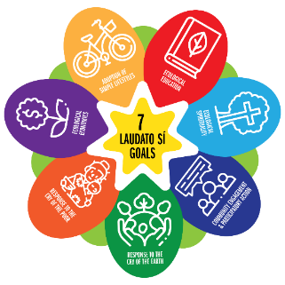

Adoption of a Sustainable Lifestyle
The Church of the Resurrection always looks for ways to be more sustainable. During the Christmas season, in an effort to keep unused or broken Christmas lights out of the landfill, 1,200+ pounds of lights were collected and taken to the city’s recycling center. This is a project that begins just before Thanksgiving and ends in mid-January.
The restrooms near the school gymnasium were outfitted with new energy efficient lighting this year. And as is our tradition, our Creation Care Team worked hard to make sure our annual parish festival remained as sustainable as possible using washable platters and silverware and compostable and recyclable containers elsewhere. Food scraps from the dinner were separated out and sent to the city’s composting site. We continue to be a “Styrofoam free” campus and have eliminated the use of single use plastic water bottles at all our events.

Community Resilience and Empowerment
Many of the Resurrection parishioners continue to be involved with other community agencies and organizations to advocate for the poor, the hungry, the homeless and disenfranchised, immigrants and the environment. Many parishioners are active with the St. Vincent de Paul Society, volunteering at its secondhand store and food pantry. Donations for food and paper/personal hygiene products are collected continuously throughout the year. During the Christmas season, the Sharing Tree project provided gifts and items for 204 people, including 37 families, 105 children, 40 nursing home residents, and 27 gifts for women at Mary’s Inn, a local maternity home for pregnant women who have no safe place to stay.
Several parishioners continue to be involved in Dubuque Area Congregations United (DACU) which is an interfaith organization dedicated to educating the public and serving the needs of local families and individuals. This year they held a forum on immigration, with presentations by local experts. They also organized and held a Crop Walk in September at the weekly Farmer’s Market to benefit the local food banks and Rescue Mission.
Parishioners also continue to be active in the Dubuque Interfaith Green Coalition to educate and advocate for climate justice. During the Season of Creation, this group partnered with the Iowa Faith and Climate Network to bring a speaker from that organization to Dubuque to talk about their new focus to educate people on climate issues and provide resources to churches and congregations.

Ecological Economics
Our parish continues to explore installation of solar panels on campus. We still need to obtain the required zoning permits from the city of Dubuque.

Response to the Cry of the Earth
The most exciting thing that happened in our parish this year was the roll out of our Green Space Development program. The mission statement for this project is simple,
“Discover your faith inf God’s gift of creation: Watch it grow.”
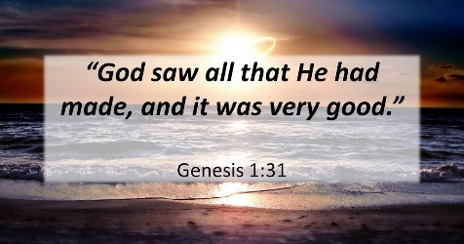

The program was presented to the parish in March as spring was unfolding and the response has been positive. In June, with the guidance and assistance of the U.S. Fish and Wildlife Service, three acres of land was seeded for a prairie. We have agreed to a ten-year commitment to monitor and care for this prairie. Once established, paths will be developed around the perimeter and within the prairie to allow parishioners and people in the surrounding community to discover a place for quiet reflection within the “cathedral of creation.” We hope to install benches and other focal points to enhance this experience. This fall, we were excited to see blooms of New England Asters and Goldenrod on the periphery of the prairie, a favorite feeding site for monarch butterflies and other pollinators.
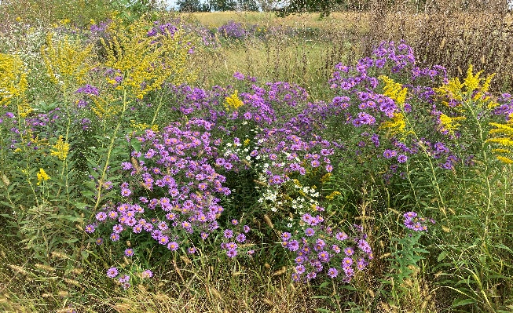

In May, during Laudato Si’ week, the Sisters of the Presentation here in Dubuque planted a native red bud tree with the help of our Resurrection school children. This tree has been blessed and carefully watered and cared for throughout the summer and we look forward to its beautiful pink blossoms in the spring.

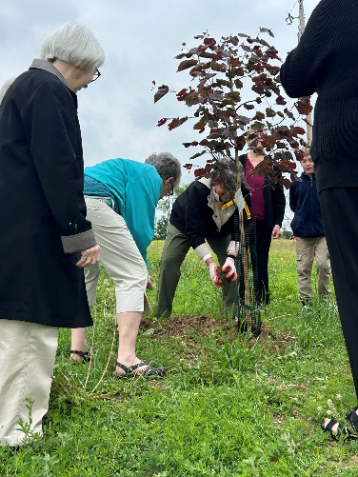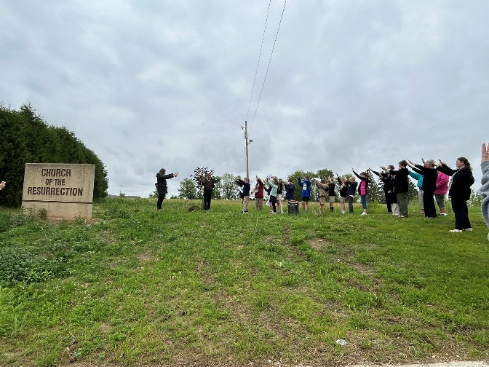

With the assistance of several students from Wahlert Catholic High School, we have also prepared a 10 foot by 14-foot site for a pocket prairie in front of our elementary school to be planted with 80 native plant plugs in the spring of 2026. This was a project proposed by one of our parishioners and will involve a partnership with the Dubuque County Conservation Board. This project is designed to provide native plants and habitat for butterflies and other pollinators while involving our grade school children in the process. According to the principal of the school, this will coordinate nicely with their science and reading curriculum.

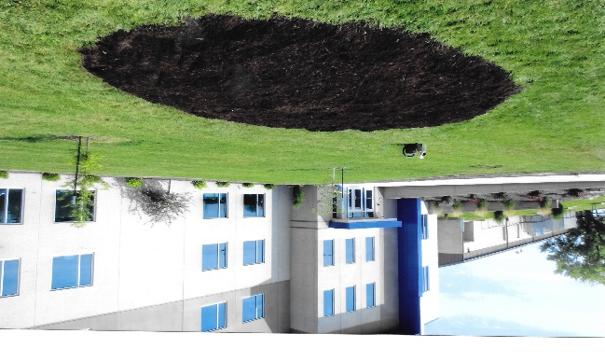
Our Youth Group researched, built and planted several container gardens using 5-gallon buckets that were designed to self-water throughout the summer. They planted vegetables and herbs in addition to planting and maintaining the two raised beds placed last year. We hope to expand on these projects in the future.
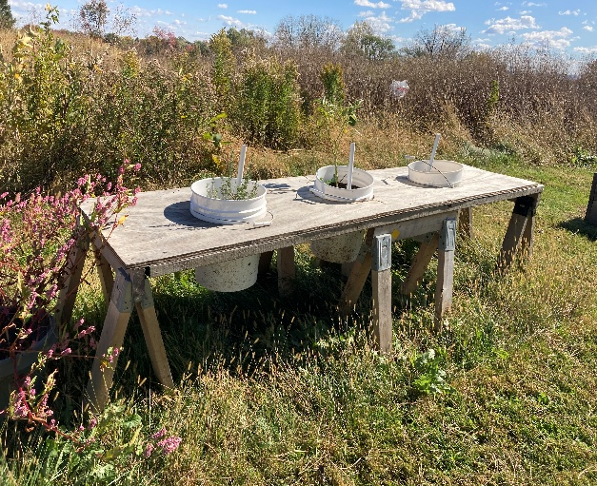

Ecological Education
In addition to incorporating environmental opportunities with our grade school children, the school has developed a Green Vision Committee consisting of interested parents and staff. Our Social Justice Committee has been using elements of Catholic Social Teaching to informally educate our parishioners on environmental stewardship issues using literature placed in the church pews, in our church social space and on our social justice Facebook page. During Lent, our Creation Care Team sponsored a book read using the book “Green Saints for a Green Generation.” It is our hope to continue to expand these educational opportunities as we develop our prairie and adjacent areas further.

Ecological Spirituality
We continue to struggle to find ways to celebrate liturgy and prayer outside. This will remain a focus for us in the year ahead. However, in collaboration with the Dubuque Interfaith Green Coalition during the Season of Creation, parishioners were invited to participate in contemplative walks using Via Creationis, along the bluffs above the Mississippi River and at the Dubuque Arboretum and Botanical Gardens Japanese Garden. This did fit in nicely with this year’s theme of Peace with Creation and the symbol of A Garden of Peace. Our Deacon Mike also continued his tradition of blessing the animals on the feast of St. Francis of Assisi on October 4th.

Response to the Cry of the Poor
Our parish continues to hold food pantries every quarter throughout the year. Typically, we distribute food boxes to about 150 families at these events. Last year, we began distributing Thanksgiving food boxes as well and are hoping to distribute 200 Thanksgiving boxes this year. We recently raised a significant amount of money to cover the cost of these activities. The generosity of our parishioners is amazing.
For the first time in many years, our parish participated in the Catholic Relief Services Rice Bowl Campaign. This was well received, and we hope to make this an annual event.
Members of our parish continue to minister to the homeless and poor by serving meals at the Dubuque Rescue Mission and at St. Patrick’s Church here in Dubuque which is a weekly community meal site.
This month, our Social Justice Committee held an Immigration Forum to educate our parishioners and the community at large on the facts about immigration. Guest speakers included an immigration attorney, and two immigration advocates who work closely within the immigrant community. It was very successful with 120 people attending.

Conclusion
Many members of our parish remain committed to good stewardship through their volunteer and advocacy activities. We continue to encourage others to make a commitment to be involved. We recently held a Ministry Fair to highlight the many volunteer opportunities available here.
As we look toward the future, we hope to organize more opportunities for outdoor worship. With the continued development of our prairie and other areas conducive to reflection on our campus, we hope to instill in our parishioners a true appreciation of the natural world, the gifts of creation, and our connection to it all. This seems to be the one area that is most in need of development at our church. Educating parish members on Catholic Social Teaching regarding the care of creation will be highlighted. We will continue to collaborate with the staff at our school to facilitate curiosity about and care of creation with our elementary students.
Our Social Justice Committee is planning an event in April around Earth Day. I anticipate the resources from the Catholic Climate Covenant will be helpful in our planning, and we hope to focus on an educational or worship component, as well as a “hands on” activity. Our prairie is planted, but there is still a lot of space on our campus that can be developed further.
Our archdiocese is currently undergoing a transition, and clergy and parish members are currently meeting to discuss plans to form pastorates within the next year. This presents both challenges and opportunities as we evaluate our collective strengths and weaknesses as parishes combine. While stressful, we remain committed to work through these challenges and have confidence that new paths will be made clear to us on this journey of faith.

