National Environment Day is one of the important moments to reflect and take action to maintain the earth's sleepiness. January 10, 2025 is a national environment day for the Indonesian nation. This celebration was held to increase public awareness of the importance of protecting and preserving the environment. As a country with high biodiversity, Indonesia faces various serious environmental problems such as pollution.
In this case, the Catholic Church calls on all Catholics to care for the environment. Concern for the environment is carried out with various concrete actions such as joint prayer, mutual cooperation, cleaning the yard, planting trees, reducing plastic waste, organic gardening, and caring for and maintaining the cleanliness of the environment. In this case, religious sisters also take part in real action in educating the surrounding community and young people. With this environmental care movement, the sisters hope that this environmental care activity can be continued by all levels of society so that a safe, clean and tidy environment can be created so that the ecosystem that lives in it can also be maintained.
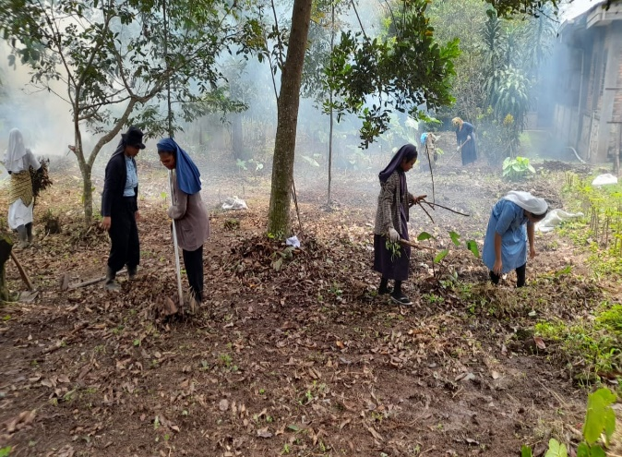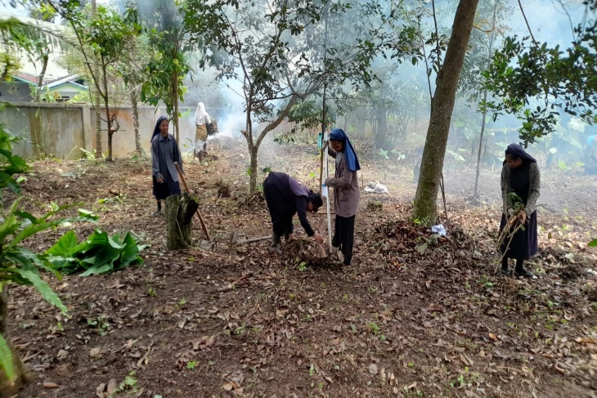
JPIC FCJM (Sr. Tarcisia FCJM)

