4 OCTOBER. It’s the feast of St Francis, the patron saint of animals. Let’s Rejoice!
ARE YOU A PET LOVER, DO YOU STILL HAVE FOND MEMORIES OF THE PETS YOU LOVED AND LOST ? Why not join us on FRIDAY MORNING 4 OCTOBER At 11am in the clubhouse to praise and thank God for animals and pets and the blessing they are
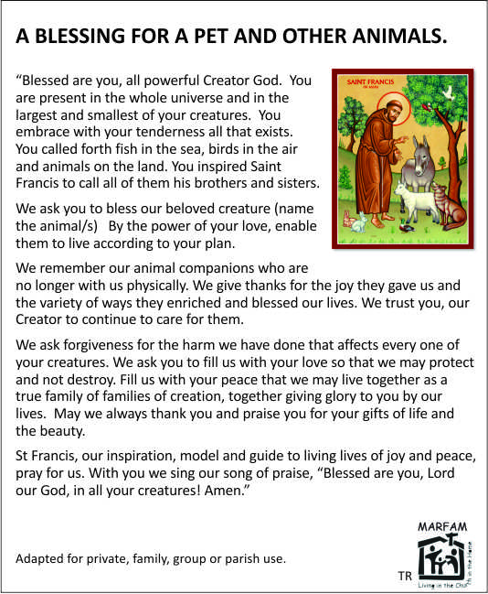
ALL THINGS BRIGHT AND BEAUTIFUL

  - Refrain:
All things bright and beautiful,
All creatures great and small,
All things wise and wonderful:
The Lord God made them all.
- Each little flow’r that opens,
Each little bird that sings,
He made their glowing colors,
He made their tiny wings.
- The purple-headed mountains,
The river running by,
The sunset and the morning
That brightens up the sky.
- The cold wind in the winter,
The pleasant summer sun,
The ripe fruits in the garden,
He made them every one.
- The tall trees in the greenwood,
The meadows where we play,
The rushes by the water,
To gather every day.
- He gave us eyes to see them,
And lips that we might tell
How great is God Almighty,
Who has made all things well
St Francis Day Blessing MdO 4 October 2024
Bring pics. Blessing prayer and hymn. Sit at tables
- Welcome, intro. Context and share Season of Creation (other sheet) animals and pets. General.
- Reading blessing line by line, reflect
- Share on our own animal/pet. Who, what, favourite memories. Pics. Pearl’s baby birds.
- Ask God to bless pet and us.
- Encourage us to work for pet care. biodiversity loss, SPCA, AACL +
- Coffee, tea. Rusks

INVITE SoC closing 3pm .

