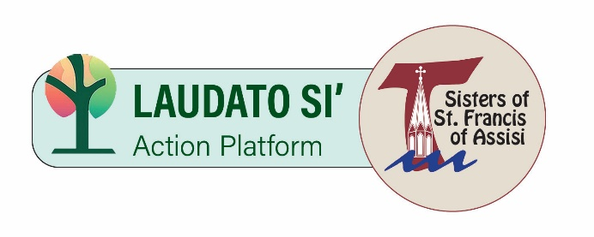
Sisters of St. Francis of Assisi
Laudato Si’ Action Platform Year 1 Goals
August 1, 2023 – July 31, 2024
Final Report

Response to the Cry of the Poor
Continue resident Sisters’ hands-on ministry providing homemade food to serve people in poverty, experiencing homelessness, or healing from sex trafficking.
Each month, Sisters engaged in a hands-on service project to benefit people in poverty. These included
- making bag lunches, and hot meals
- conducting food drives
- crocheting mercy mats, hats and scarves
Each service session included prayer for the recipients. Sisters participate annually in the Capuchin Walk for the Hungry and have done so for many years.

In collaboration with LCWR-9 congregations, fund an awareness/information campaign about human trafficking in northern Wisconsin.
For the second year, Sisters funded educational materials in a magazine and in rest stop card racks as resource for people being trafficked and to help citizens identify signs of human trafficking. Sisters also participated in the Department of Homeland Security Blue Campaign with prayer and awareness about human trafficking.

Response to the Cry of the Earth
Continue developing a bird sanctuary on convent grounds.
Gourds grown in convent gardens were hollowed, painted, and hung for small bird nesting. Plastic lawn signs were recycled into housing for Purple Martins. Additionally, there are bird baths, feeders and a fountain frequented by various birds.

Form a committee to explore the feasibility of installing solar panels on convent buildings.
A site visit with convent maintenance director, a contractor and a solar installation expert showed that the convent roof and outbuildings are not viable for solar panels.
The new Franciscan Shore sign is lighted via solar power.
Wiring for six Electric Vehicle charging stations was installed as part of the Franciscan Shore parking lot restructuring.

Ecological Education
Monthly Justice and Peace livestream programs will feature Laudato Si’ content and connections.
Programs included
- Franciscan Foundations in Laudato Si’
- Season of Creation Ecumenical Prayer
- International Day of Peace Prayer
- Land Acknowledgement Ceremony honoring Indigenous Peoples with guests from Congregation of the Great Spirit
- Prayer Against Gun Violence
- Wear Blue Human Trafficking Awareness
- Adoption of Sustainable Lifestyles
- Cameroon Goats and Chickens Project
- Earth Day Prayer
- StreetLife Communities Serving People in Homelessness
- Perspective on Palestine

Begin a resident Sister-led Laudato Si’ book study group.
Sisters Felicia Schlechter and Helene Mertes led “Lunch and Learn” small group discussions monthly from September 2023 through February 2024. Each session focused on a chapter from Laudato Si’ and included prayer for God’s creation.

Ecological Economics
Animate Sisters and Associates to contact their legislators urging funding support for aid to farmers, for food programs, and to protect the environment.
Campaigns included support for the Farm Bill 2023, the FOREST Act, gun control legislation, Healing our Waters budget asks for Great Lakes Water Restoration Initiatives, and more.

Ecological Spirituality
Expand offerings for Sisters and Associates to pray with and in God’s creation through Justice and Peace livestreams, Season of Creation, pilgrimages, and outdoor prayer services.
Sisters participated in monthly outdoor prayer experiences in collaboration with the pastoral care associate and JPIC.
- Pilgrimages included Mequon Nature Preserve, Water Witness at South Shore Park, and Wehr Nature Center
- Season of Creation prayer featured Scripture reflections by Sister Mary Kemen, Sister Helene Mertes and Sister Linda Greenwood
- See Ecological Education for additional programs.

In preparation for International Day of Peace, refurbish the peace pole on convent grounds and develop a land acknowledgement statement.
The Day of Peace celebration included refurbished peace pole blessing, land acknowledgement, and guests from Congregation of the Great Spirit.

Adopt Sustainable Lifestyles
Form a committee of resident Sisters to research sustainable practices in convent food service, housekeeping, and nursing, and write proposals before meeting with the Administrator and appropriate department heads for implementation.
Resident Sisters Felicia Schlechter, Mary Hau, Jean Mariani, and the late Barbara Barry, and Rose Kordick collaborated to implement sustainable practices in convent residences. Achievements include
- Creating guidelines for composting from kitchen and resident Sister apartments
- Replacing Styrofoam food to-go containers with recyclable cardboard
- Minimizing use of plastic utensils, cups and food containers
- Encouraging Meatless Meal options
- Creating guidelines for recycling household items like batteries, lightbulbs, cassette tapes, etc.
- Encouraging use of paper medication dispensing cups over plastic
- Encouraging use of non-toxic cleaning products in housekeeping
- Raising awareness about paper, ink, and electronic conservation and recycling

Community Resilience and Empowerment
Continue to inform the community about legislation, its impact and, as possible, include Sister and Associates in sign-on and letter-writing campaigns.
In addition to actions listed under Ecological Economics, community engagement also included
- Garden Blessing for the MacCanon Brown Homeless Sanctuary
- We of Nojoshing article researched and written by Sister Rose Kordick honoring indigenous people in the history of convent grounds
- Tips for recycling and composting shared with staff and associates
- Coordinating legislative prayer partners for eight congregations of women religious
- Prayer and legislative advocacy against gun violence
- Solidarity statements in support of Trans Day of Visibility
- Advocacy letters supporting immigrants, and adding our voice to the Catholic letter on Israel-Palestine.

