43 Abercrombie Ave
Seven Hills 2147
3rd May, 2024

The accompanying paper, Eco-consciousness, is supposed to lead the way to a story of creation with the Holy Spirit being the life within the universe and Earth also alive in the Holy Spirit. I hope what I have written will stimulate discussion towards unlearning past worldviews and clear a way to accept a new story beginning with the Holy Spirit.

As Ilia Delio said, “I do not think that we have a functioning trinitarian theology” and I think this is going to be a stumbling block for a long time.

My reflection ‘Eco-consciousness’ follows:

Eco-consciousness
Revised 3. 5. 2024 Frank Richardson frichardson131@gmail.com
Let us begin by paying our respect to the original inhabitants of our land who kept alive their kinship with all living beings and holding on to the knowledge of the Great Spirit in everything and following a sustainable way of life conscious of the environment and using intelligence and reason, learned to live according to the capacity of their land and the seasons with customs and laws within a conservation ethic.
Pope Francis concurs, Human groupings have often “created” an environment, reshaping it in some way without destroying it or endangering it. LD 27

Earth is alive and is the environment in which everything lives. It is commonly held that Earth is God's gift to us.
When Stephen Hawking was asked why he did not believe in God. He replied: “Your God is too small.” Another time he said, “The future scientists would be mystics and science itself would be mysticism.” Which declares Science and Religion will have to find a united expression of God's presence in Creation.
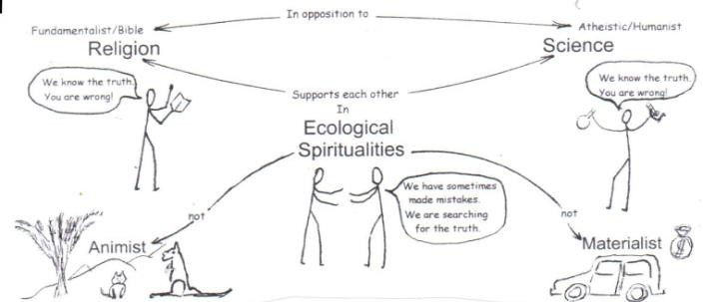
Ecological Conversion will have shallow roots unless there is a common story.

Religions declare they have The Truth which never changes. Scientists can only say they are revealing the truth by examining the world. Science cannot be completely true without God, and religion will not be true while it ignores the findings of science. God is so much more that human words can express yet all religions try to confine God to a description within some ancient written word.
Yes, there are many contradictions in religious language making the meaning less coherent. The Holy Spirit’s role as Giver of Life has been poorly explained. How long did we keep saying, “I believe in The Holy Spirit, Lord and giver of Life.” Followed
by a contrary statement, “Who proceeds from the Father and the Son.”

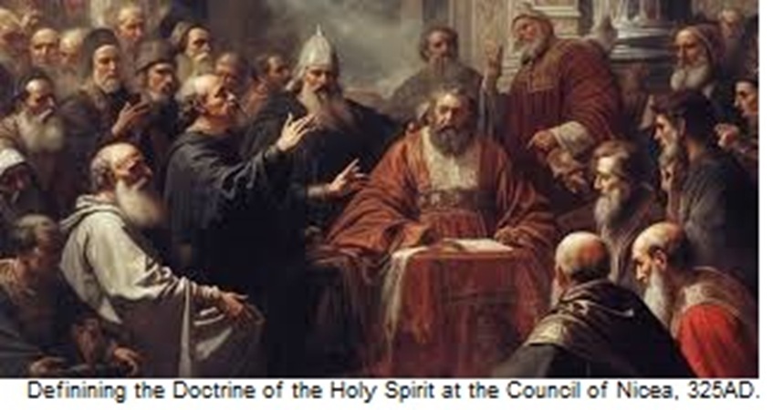
Here we have a statement that the Holy Spirit is generated through the union of two male figures and the Holy Spirit is always referred to with a masculine pronoun. Perfect evidence of a thoroughly Patriarchal basis that has guided religious thinking for centuries.
Has anyone considered how a male Spirit proceeding from a male-male beginning is so contrary to anything known in nature? Being made in God's image means we should be turning our thinking towards all nature to see the nature of God.
It also seems that the Incarnated one, the Son has been placed before the Giver of Life, and that is an inversion of reality. This has resulted in a preoccupation with the divine and human natures of Jesus clouding the view of the Trinity. The divine nature of our human life has been overlooked to look on Jesus as God to be worshipped instead of an example to be imitated. It also means that the Holy Spirit’s presence as The Life in creation has been subdued, if not neglected. Dairmuid O’Murchu explains,

“My suggested revamping of the Holy Spirit begins with the dimensions of the living Spirit, the foundational energy that inspires even God’s own creativity, encapsulated in the notion of a Father/Mother creator.” 1
Early in the bible the Book of Job tells us how to discover God’s life.

“But ask the animals, and they will teach you, or the birds in the sky, and they will tell you; or speak to the earth, and it will teach you, or let the fish in the sea inform you. Which of all these does not know that the hand of the LORD has done this? In his hand is the life of every creature and the breath of all mankind.
Job 12:7-10
This New Story of the beginning and the evolution of creation can be better understood, by looking at a process in nature that we know well. It is the pattern in which all new living beings begin. It happens like this:
A collection of atoms from a male enters a female enclosure containing a similar collection of atoms. Something happens. Is it competition or chaos that erupts? In a short time, however, the atoms without further outside guidance have made their choices, and a single set of atoms emerges as a new genetic plan. Now as a single cell, it will make a replica of itself, and the two will in turn keep making more, each new cell having autonomous being in this new life. To keep growing, the surrounding environment will need to supply a source of atoms especially Oxygen, Carbon and Hydrogen. I wonder if it will become a plant, an insect, an animal or even a new human life.
For the past century or so, we have been given a good idea of what the Cosmos is, when it started and how big it is. Science has also been searching for the smallest things, the building blocks that God provided as the foundation stones on which creation is built. Quantum Physics has revealed that there is energy in the forces and fields within the particles from which atoms of matter are built. Atoms are bundles of pulsating energy.
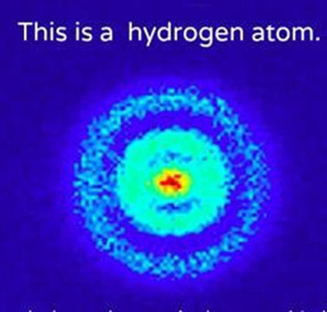
From the very beginning, the Holy Spirit bestowed her life-energy through the forces and fields that gave rise to multitudes of quantum particles. Despite the vast numbers, just three of these particles joined as a community to become atoms of matter. This union of three particles, Proton, Neutron and Electron, became the atom, hydrogen, which is so much more than any of the particles could be on their own. They would be the makers of all the visible matter in our universe. Within each of the growing number of heavier atoms is the life-energy of the Holy Spirit with such qualities as consciousness, memory and creativity leading to what we now know as the
universe.

Nature with a Spiritual Life
Scientists can explain the physical existence of atoms, but finding divine life in them is beyond scientific discovery. Science has no test for understanding the divine origin of the energy in the fields and forces that work together to guide what matter can achieve. This is a matter of Faith for those who are prepared to search. Thomas Berry started the break from the Genesis account of creation to one that fits the world we can observe in real life. He has connected science and religion in The New Story of creation.
Thomas Aquinas taught that a mistake about understanding creation results in a mistake about understanding God. Here we may add, a mistake in understanding the Holy Spirit results in misunderstanding our relationship with God. Our soul is the life of the Holy Spirit keeping alive all the matter that we call our body. The body belongs to Earth as a collection of atoms and its life is soul or grace which belongs to the Holy Spirit.
As a metaphor for our connection to God, consider a living blood cell coursing through the body of a fish. The internal workings of the fish made the blood cell with atoms collected from what it consumes. Although the blood cell is alive, for it contains the fish’s DNA, it does not know it is a vital part of the fish, yet it is contributing to the life of the fish and cannot live apart from the fish. After a brief life, the blood cell will be absorbed into the fish body or expelled into the marine environment.
In a similar way, although I live in God, I cannot see God nor the Spirit, but I believe I am living in and contributing to the life of God by living in God. My being comes from a lengthy line of ancestors from before and during Earth’s evolution. The consciousness, memories and creative urge of millions of beings are carried in the billions of atoms that make me. My life is connected to all the past and present life of Earth, and while alive I am helping to create a future Earth for the continuation of life. I can only be alive, however, for the duration of my living with God's spirit which I call my soul or God's grace. Then the atoms of my body return to Earth and the spirit returns to live in the wholeness the Holy Spirit.

Yes, animals, birds and fish and all of nature can help explain the story of my relationship with God. Australian Indigenous people can say, ‘Earth is our Mother’ for the soil, the plants and the animals are vessels of the living Spirit. Does God have a gender? It would be quite natural for people to suppose this. Some ancient mythologies tell of a Father/Mother God giving birth to all creation. Tenderness of a loving God is beautifully supported by Sean McDonagh.
“Finally, there is the feminine dimension of God which we identify with the Holy Spirit. She is the principle of communion, binding all reality together. The Holy Spirit is the source of all unity. All attraction, all bonding, all intimacy and communion flow from the Spirit. Each of these relationships is sacred to the Spirit. In her the whole universe is linked together in one nurturing, enveloping embrace. She is the one who inspires all fruitfulness and creativity – which are the signs of true bonding and intimacy. From her comes the great urge to heal what is broken, re-unite what is separated, and recreate the face of the Earth.”
From the very beginning of creation elements and molecules have bonded in creative relationships in which they give up their former identity to become something completely different and capable of more. Even at this elementary level this is love. With every small act, we also give a little of ourselves. Kind acts are life-giving, unkind acts are life-destroying. If we give a stranger a smiling greeting and it is returned in like manner our life receives a little sparkle. True love happens when two people find a partner to whom they are prepared to give themselves completely, despite all the difficulties that that entails. Evolution needs communities of loving companionship which includes the natural world in community with human life. The Kingdom of God in the here-and-now exists in communities in relationships of justice and compassion.
Ecosystems are communities of support for all the members. It is the interconnectedness of all the micro and macro lives in these communities that creates a healthy ecology. For us, to be co-creators with the Holy Spirit means learning about the natural world and the lives of all the other members of the Earth Community.
Many scientists are studying ecology in detail and sharing their knowledge of the wonders of life in a growing library of books and films. To understand the God of Creation, studies of natural life and Spirit life must be integrated into human-divine wholeness.
Theologians traditionally have studied and taught the dimensions of the transcendental Spirit world. Now they must include the Spirit alive in the earthly Creation as sacred study, even getting their hands soiled by immersing themselves into the natural world, and by accepting that the lives of plants and animals are agents active in the creation of human life. Ecosystems are making life possible in the receiving and giving back the matter that first brought life from soil. Even the solid rock of mountains that one day may crumble to soil can be counted among the creators of life. Being the essence of humility God has allowed the atoms of matter of the universe complete freedom as to how they should use their consciousness in uniting the energy of the Holy Spirit to creates life. The life-energy of the Holy Spirit in every atom of matter has been working towards creating the world in God’s image since the beginning. Now, human life has inherited the responsibility for continuing creation. The continual separation between theology and worldly knowledge is like a wall preventing religions from uniting in the Ecological Conversion so urgently needed.
The Science/Religion divide is only one of the many causes of the catastrophic environmental harm and changing climate, every sphere of public life has great divisions, mostly caused by personal, human interests and fundamentalist beliefs. Religions of the world, working together, have to lead the way starting a dialogue on how to discern the wholeness of life in The Holy Spirit.
Instead of growing into one Family of God, religions are dividing into different churches, and within religions the members are polarized in their views of correctness. In the secular world, instead of becoming one with all life, a growing part of humanity has chosen an illusion of separateness whereby they deserve a greater share of the goods of life. The self-centered ones whose aim is to have more, deprive the marginalised, the dispossessed, the homeless and refugees of a just sharing of Earth’s goods, without any sign of compassion.
With all the collective consciousness, memory and creativity that is within the worldwide human community, there is all that is needed for the Kingdom of God to be realised in the here-and-now world.
I pray that they all be one, even as you, Father, are in me, and I in you, that they also may be in us. I in them and you in me, that they may become perfectly one. John 17:21, 23

Endnotes:
I urgently appeal, then, for a new dialogue about how we are shaping the future of our planet. We need a conversation which includes everyone, since the environmental challenge we are undergoing, and its human roots, concern and affect us all. . . . Everyone’s talents and involvement are needed to redress the damage caused by human abuse of God’s creation”. All of us can cooperate as instruments of God for the care of creation, each according to his or her own culture, experience, involvements and talents. Laudato Si 14

ii Berry, Thomas; The Dream of the Earth. San Francisco: Sierra Club, 1988
Thomas Berry offers a new perspective that recasts our understanding of science, technology, politics, religion, ecology, and education. He shows us why it is important for us to respond to the Earth’s need for planetary renewal, and what we must do to break free of the “technological trance” that drives a misguided dream of progress. Only then, he suggests, can we foster mutually enhancing human-Earth relationships that can heal our traumatized global biosystem.
111 McDonagh, Sean; 1986. To Care for The Earth, A call to a new theology; Bear& Co. P119
iv Greater investment needs to be made in research aimed at understanding more fully the functioning of ecosystems and adequately analysing the different variables associated with any significant modification of the environment. Because all creatures are connected, each must be cherished with love and respect, for all of us as living creatures are dependent on one another. Laudato Si 42
v This implies a relationship of mutual responsibility between human beings and nature. Each community can take from the bounty of the earth whatever it needs for subsistence, but it also has the duty to protect the earth and to ensure its fruitfulness for coming generations. LS.67 and The natural environment is a collective good, the patrimony of all humanity and the responsibility of everyone. If we make something our own, it is only to administer it for the good of all. Laudato Si 95.

vi Delio. Ilia; Making All Things New: Catholicity, Cosmology, Consciousness. Orbis, Maryknoll, 2015.
Sr Ilia Delio expresses the need for the human race to re-assess their lack of awareness of being parts of a whole, and wake up to the destructive, self-centered way we are generally acting towards the life of Earth. Humans must learn to cooperate with all life in creating a better future.

