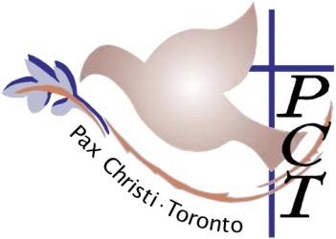

Pax Christi Toronto
607 - 655 Broadview Ave.
Toronto, ON,
M4K 2P3

January 8, 2024

To the Laudato Si' Action Platform Team:

Pax Christi Toronto, as a member of the Laudato Si' Action Platform is pleased to share our report on activities for 2023 and 2024 Plans as they relate to the Laudato Si' Action goals.

Pax Christi Toronto, a member of Pax Christi International, is a Catholic Peace movement which promotes peace, respect for human rights, justice and reconciliation throughout the world. It heeds the Gospel call for Active Non-violence and seeks to address the root causes and the destructive consequences of violent conflict and war. This guides all of our activities and our advocacy for human rights and ecological justice.

A peaceful existence is dependent upon a harmonious relationship between God, humanity and the natural environment. Pax Christi Toronto's mission is the promotion of Peace, and we believe that a healthy environment that provides for all our needs is one of the necessary prerequisites for Peace. War is violence against the earth and its people and destroys the possibility of a life of peace for humans and our companion species and brings with it many perils, environmental destruction, immeasurable hardship and death.

A degraded environment can also create the conditions for war, forced displacement, and competition over scarce resources which can lead to conflict. We therefore support actions to reduce greenhouse gas emissions, the major cause of climate change and support a just transition to renewable energy sources and more responsible policies to ensure environmental sustainability, both domestically and internationally.

The year 2023 with armed conflicts in Ukraine and Palestine has underscored the tragedy of warfare and its toll on human life and destruction of the environment. We are firmly opposed to war in all its forms and advocate for non-violent, diplomatic means to resolve conflicts. Many of the activities undertaken by Pax Christi Toronto in the past year and planned activities for 2024 are to advocate for an end to war, and militarism, and to advocate for peaceful solutions to protect life in all its forms.

We look forward to journeying together with others in the Laudato Si' Action Platform on the path towards Integral Ecology and attach our summary of current activities and planned actions for 2024.

Respectfully submitted,

PAX CHRISTI TORONTO

Discernment Team
:aos
Attach: PCT Activities 2023-2024

