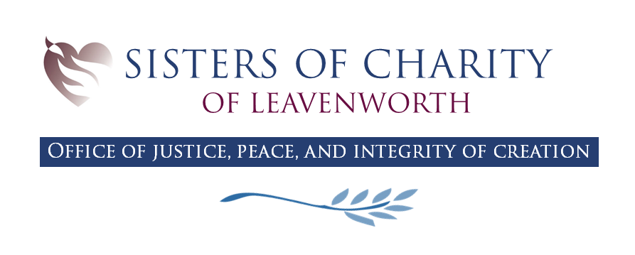

Laudato Si’ Action Platform Year 2 Review

Our continued commitment to Laudato Si’
We have worked diligently to spread the message of Laudato Si’ and the mindset of integral ecology throughout our community. Our commitment goes beyond a platform, program, or initiative, and it is not simply another project amidst a sea of projects. We are intentional about incorporating the mindset of integral ecology into everything that we do. We continue striving to do the work articulated in our mission statement to “offer every loving service in our power to meet the critical needs of God’s people”, and we go about this with the knowledge that because everything is interconnected, our service ripples outward. We identify the critical needs of God’s people, then we draw the lines of connection between the issues we address and the effect it has on all other social and environmental systems. In this way, we seek to permeate integral ecology into every part of our work and lives as a new way of being, calling us into deeper connection with our sisters and brothers.

Interest Groups
The Sisters of Charity of Leavenworth had four self-coordinating interest groups this year: Seeking Racial Justice, Immigration, Care of Creation, and Human Trafficking.
Throughout their meetings, these interest groups are striving to look at their particular issue through the lens of integral ecology. For example, the Immigration interest group is educating themselves about how the climate crisis is contributing to greater numbers of refugees and immigrants. It is our hope that practices such as these will lead to greater collaboration among the interest groups to meet the needs of the marginalized communities they wish to serve.
The increasing awareness of interconnectedness is also encouraging interest groups to reach out beyond the community of Sisters and Associates. The Care of Creation interest group, for example, invited nearby Leavenworth churches to help plan Season of Creation activities. This resulted in a collaboratively planned prayer service at a local park overlooking the Missouri River, a Blessing of the Animals service at a local parish, and a prayer service at the Sisters’ chapel led by students in a local middle school. The interest group hopes that next year’s Season of Creation planning can include even more Leavenworth community members.

The Integral Ecology Initiative
One example of our restructuring through the lens offered by Laudato Si’ is the Integral Ecology Initiative. This initiative is a way of reimaging our relationship with our three sponsored ministries: University of St. Mary, Christo Rey Kansas City High School, and El Centro Pastoral de San Vicente. In the spirit of interconnectedness, we recognize that our relationships can no longer be hierarchal or transactional. Each of the four institutions contribute uniquely to our mission, bringing their own skills, resources, and character.
Through the Integral Ecology Initiative, we are seeking pathways to work together, supporting our mission in more relational and life-giving ways for each institution. Specifically, we have begun designing a container which will support collaboration, dialogue, and transparency between the four institutions. This container will bring our interconnectedness to the forefront by bringing a team of four individuals, one from each institution, to form deep relationships and engage in dialogue with each other. It is our hope that this team will, on one hand, champion mindsets of integral ecology uniquely in their respective institutions, and on the other hand, implement collaborative projects grounded in the shared knowledge, skills, and roles of each institution.

LSAP Coordinator
Considering the increased energy and resources we wanted to devote to Laudato Si’ and Integral Ecology, we saw it both fitting and necessary to hire a full-time member of our JPIC office to oversee the platform and its programs. The new LSAP coordinator has steeped themselves in the rhetoric and wisdom offered in Laudato Si’ and became a certified Laudato Si’ Animator through the Laudato Si’ Movement. Soon after starting their role in March of 2023, they began contributing to the JPIC office’s weekly newsletter with a section on integral ecology. In May, they organized our community’s education around Laudato Si’ week, which culminated in screenings of the film, The Letter and a follow-up discussion about its message.
Our primary vision is for the LSAP coordinator to educate the community about Laudato Si’ and facilitate a reimagining of how we can live in ways that are aligned with integral ecology. In their first year, much of their work has been centered around meeting with Sisters, Associates, Staff, and members of the community to surface their passions and find ways to increase collaboration. Through these meetings, we recognized the presumption of isolation that many of these groups operated under, and we are currently designing a series of dialogues, events, and structural changes aimed at breaking down barriers of communication between them. We recognize that our staff and the communities we serve are not merely transactional relationships. They are our partners in mission.
There are a number of ways this role can develop in the coming years as we continue redesigning our internal community to be more reflective of integral ecology. One path may be pushing forward local projects centered around the LSAP goals, such as constructing a land ethic, regenerative landscaping, circular and sharing economy networks, food access and distribution, housing, etc. Another path may be to take such projects outside of our campus and collaborate with other organizations and community members to evaluate and address the pressing needs within Leavenworth in ways that creatively support the common good. A third path may be assisting the Leavenworth community to engage in political advocacy. Drawing from our community’s rich heritage in fighting for systemic change, we can begin passing the torch to future generations passionate about advocating for the needs of marginalized populations and the marginalized planet.

Political Advocacy
One important way we continue to embody our commitment to integral ecology is through our advocacy work at the Kansas State Capitol. This work of systemic change remains essential to us because it lays the groundwork for the ways all members of society relate to their fellow humans. Governments have the power to determine who is living on the margins and who is not. Integral ecology implores us not to accept these conditions as natural, insisting we redesign our societal systems to reflect the inherent value of all life, acknowledging the destruction that a lack of prioritization for life can result in.
This year, we worked both individually and with partners on the issues of Medicaid expansion, homelessness, climate change, and taxation. We believe advocacy on these issues to be essential in the creation of a government that supports the common good.

