“God’s People in Extraordinary Variety … A Caring Community”
Description
St. Thomas Aquinas Church is a small parish of 616 families located in mid-town Indianapolis in the racially diverse Butler-Tarkington neighborhood. As the mission statement says, “St. Thomas Aquinas Parish is an interracial and welcoming community, committed to serving the will of God and living the gospel of Jesus Christ through prayer, vibrant liturgy, educational excellence, personal sharing and social interaction. We spread our spiritual message and our human and materials resources to the city and the world, confident that a loving relationship with those in need produces mutual rewards.” | 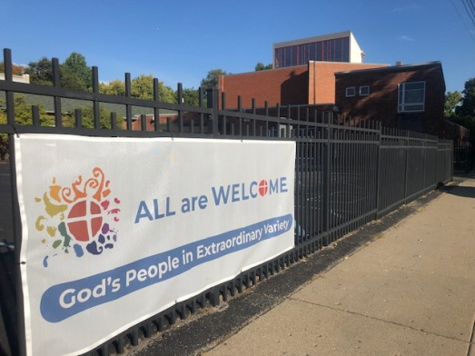
The parish takes this mission to heart. Parish ministries serve our local neighbors through a food pantry and an active St. Vincent de Paul conference and our global neighbors through Catholic Relief Services and supporting our twin parish, St. Jean-Marie Vianney, in Belle-Rivière, Haiti. Our parish welcomes all and encourages deeper connections between people from different faiths, backgrounds, and cultures through parish events, Lenten suppers, and Diversity Dinners. Nourished by Mass and the sacraments, we strive to live the gospel teachings of Jesus Christ.
Parishioners recognize and embrace this mission. When asked to describe the parish, the words most often used were community, welcoming, caring, justice and commitment.

Parish History*
St. Thomas Aquinas Parish began in 1939 with a simple wooden church in what was at that time the far north-side of Indianapolis. Education has always been an important part of the parish mission; the school began a few years later in 1941.
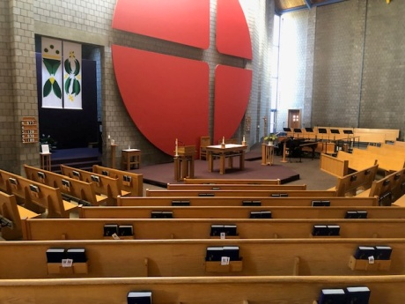 | Vatican II had a huge impact on both the physical structure and mission of the parish. Monsignor Raymond Bosler, pastor from 1963 to 1966, was a local civil rights leader who also served on the support staff of Vatican II. He brought the messages of openness and the involvement of the laity back to the parish and oversaw the planning of a new church that, in the words of architect Evan Woolens, was “a church for the new liturgy”. The grey cinderblock-style interior walls and the asymmetrical arena shape of the seating area allow the focus to be on the people in the pews, embodying the message that church is not a building, but the people of God.

A signature element of the church interior is the red circular “negative space” cross behind the altar. The cross represents two relationships: our relationship with God (the vertical line of the cross) and our relationship with our neighbors (the horizontal line). The call to care for each other is one that St. Thomas Aquinas Church takes seriously. In addition to serving local and global neighbors, care for others at STA also takes the form of social activism. In a notable case, efforts by St. Thomas parishioners led to the overturning of racially exclusive practices at a neighboring recreational and social club. STA parishioners have also marched and spoken out about gun safety, the death penalty, and an end to the Iraq occupation.
Creation Care at STA
Creation care at STA dates back to 2007, when a group of parishioners who frequently found themselves at the same environmental events decided to form a group within the parish to educate others and to address environmental concerns. Originally dubbed the “Green Committee”, the name of the group soon changed to the Creation Care Ministry with an added emphasis on the spiritual foundation for environmental action.

The mission of the ministry is “To promote the joyful stewardship of the Earth through spirituality, simplicity, and sustainability”. In 2009, the ministry identified 4 goals:
- Goal 1: To deepen the understanding that our faith calls us to care for creation and to encourage parishioners to explore the spiritual foundation of ecological actions
- Goal 2: To educate the parishioners of STA about the importance of being good stewards of our environment and to assist them to employ more eco-friendly habits in their own homes
- Goal 3: To develop concrete actions for the STA parish leaders and ministries to take that lessen any negative environmental impact from parish operations
- Goal 4: To develop a long-term environmental action plan for the parish and school

Actions to support these goals included publishing “Green Corner” environmental tips in the bulletin, film screenings, sponsoring an eco-spirituality book discussion group, presenting workshops on reducing carbon footprint, presenting Feast of St. Francis and other programs from the Catholic Climate Covenant, doing away with disposable dishes at parish events and Sunday morning coffees, encouraging recycling, and many other actions. In anticipation of the release of Laudato Si’, STA sponsored a prayer breakfast with remarks by (then) Archbishop Joseph Tobin in March of 2015. Relationships formed at that event led directly to the formation of the archdiocesan Creation Care Commission, which still includes members of the St. Thomas Aquinas Creation Care Ministry.

The release of Laudato Si’ inspired the ministry to add two additional goals:
- Goal 5: To advocate for policies that protect the natural environment and those most affected by environmental degradation
- Goal 6: To collaborate with organizations and other congregations to further creation care

Moving Forward: STA and the Laudato Si’ Action Platform
The goals of the parish Creation Care Ministry overlap with the 7 Laudato Si’ goals:
Response to the Cry of the Earth
Response to the Cry of the Poor
Ecological Economics
Adoption of Sustainable Lifestyles
Ecological Education
Ecological Spirituality
Community Resilience and Engagement

The Laudato Si’ Action Platform, in which STA officially enrolled in February, 2022, now gives the parish a framework to integrate the values and principles of Laudato Si’ (as expressed in the Laudato Si’ goals) into the parish culture and parish ministries.

* Adapted from “Our History”, written by Judith Cebula and Dan Carpenter on the 75th anniversary of the parish in 2014; https://www.staindy.org/church/history/

