We the Holy School community of Guwahati have done as per the 7 goals of the Lodato Sii which is going with the Integral Ecology.
- Response to the cry of the earth
- As a community we have made effort to save energy by switching off the lights when not needed and unplugging electronic devices when not in use.
- We use water sparingly and responsibly
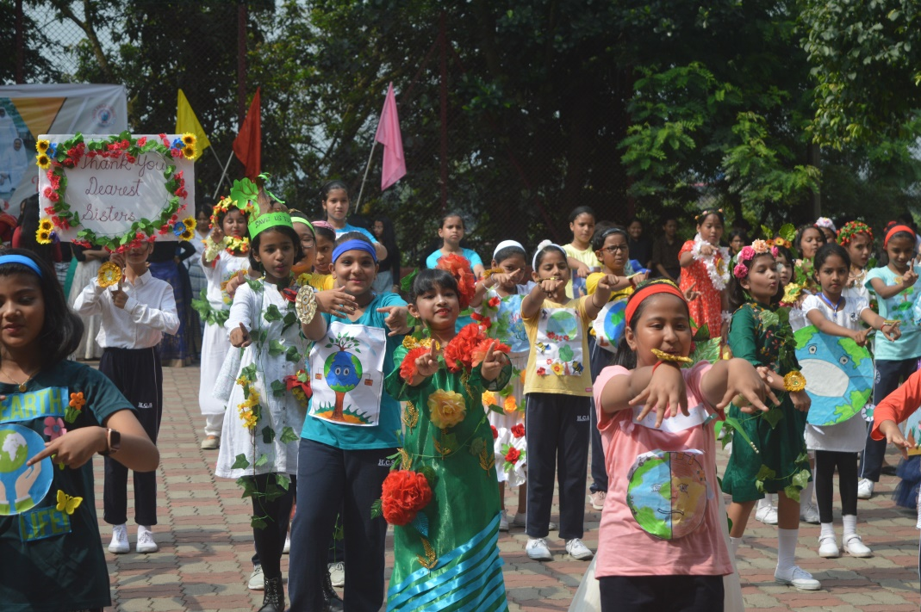
- During the golden jubilee celebration of the school we choose to use only paper packets for snacks.

- We teach students during SUPW class to prepare and use paper shopper bags and pencil and pen holders.
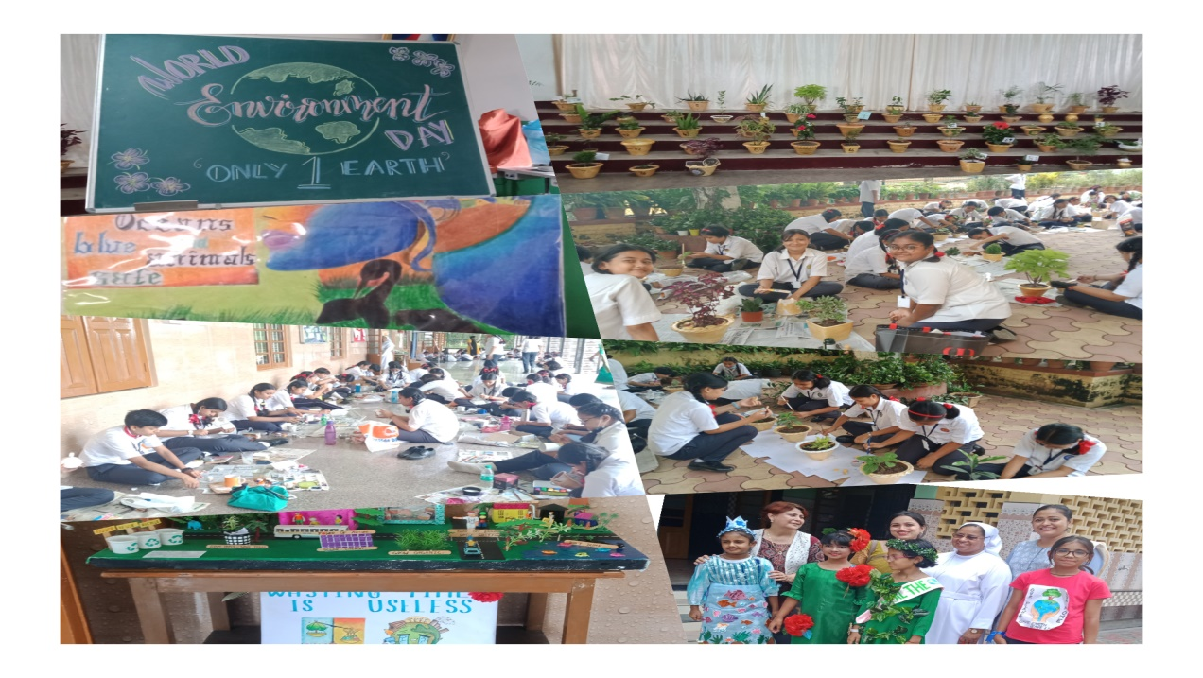

- Response to the cry of the poor
- Adopted a poor child by giving books and a bicycle to go to school.
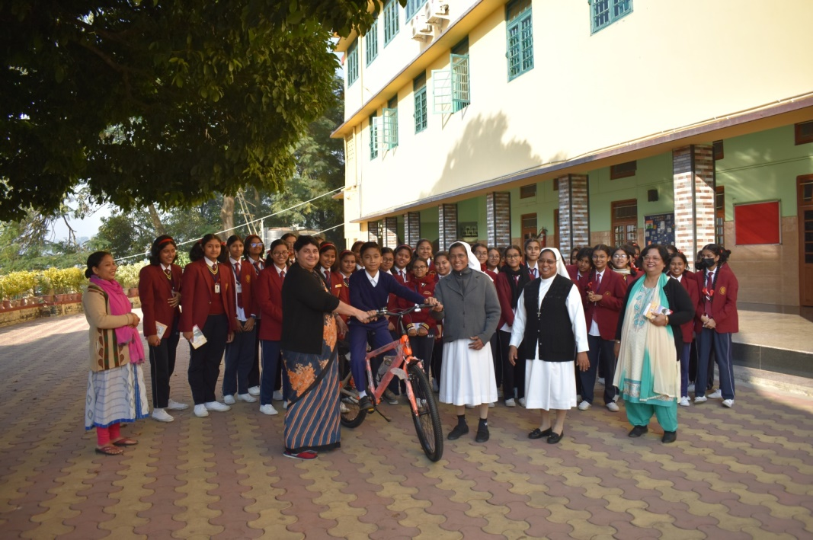

- Fees reduction is given for about 53 students and supports 12 students with free books.
- Motivated teachers to give free remedial classes to the academically poor students.
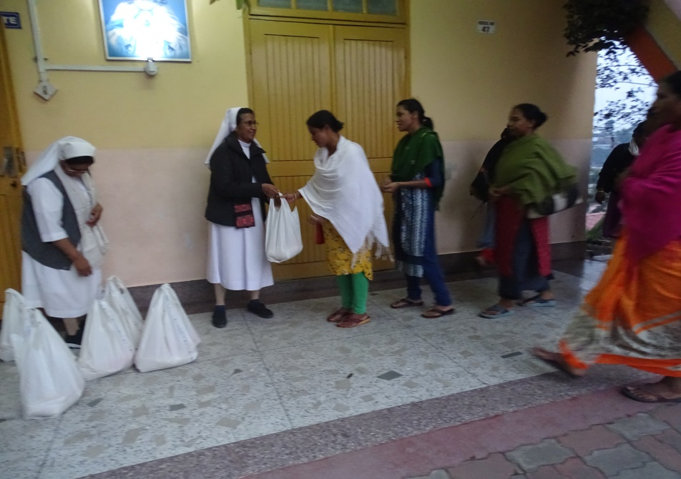

- Shared essential commodities with the poor during the Christmas celebration.
(2 photo)

- Ecological Economics
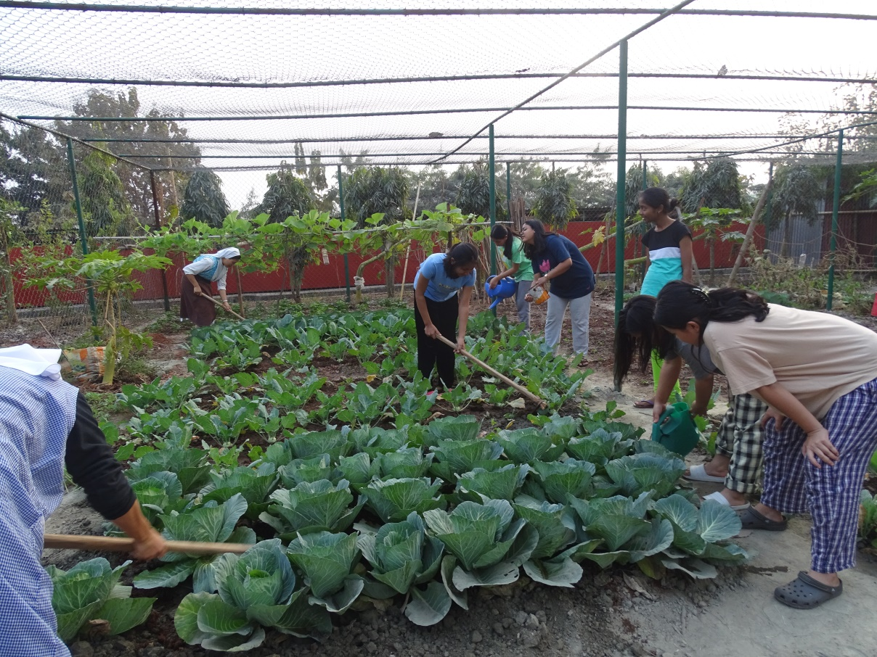

- Created and cultivated new kitchen gardens.(3 photo)
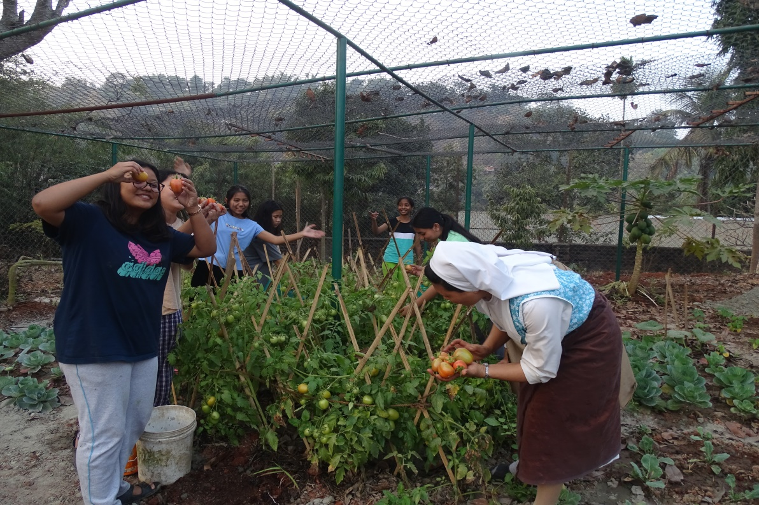

- Sustainable Ecological Education
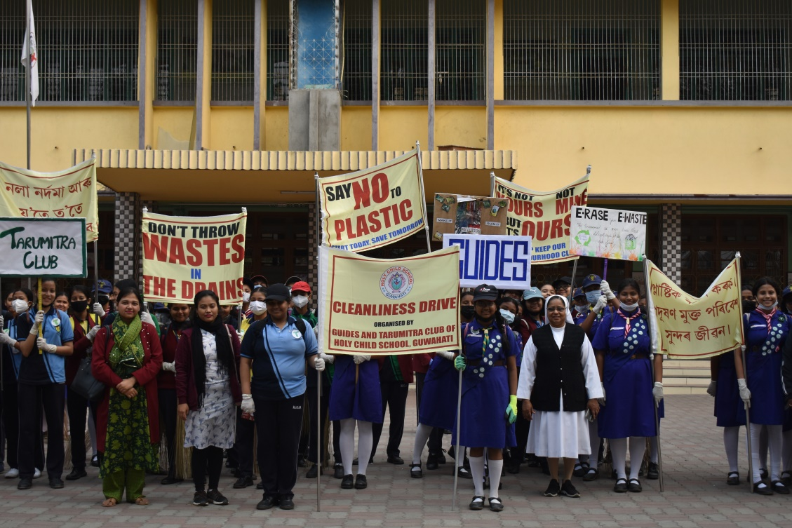

- Organized awareness rallies on ecology (4 photo)
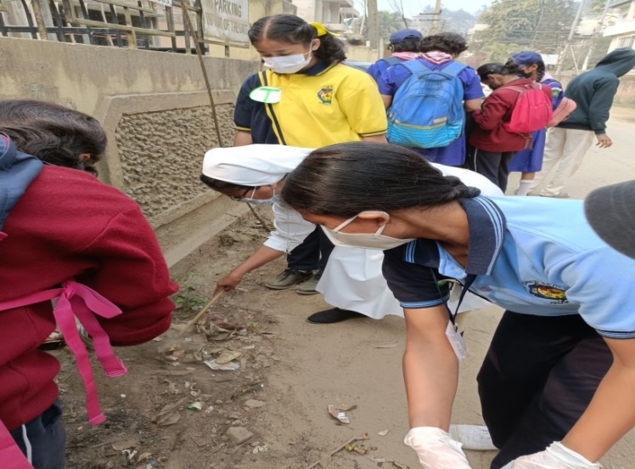
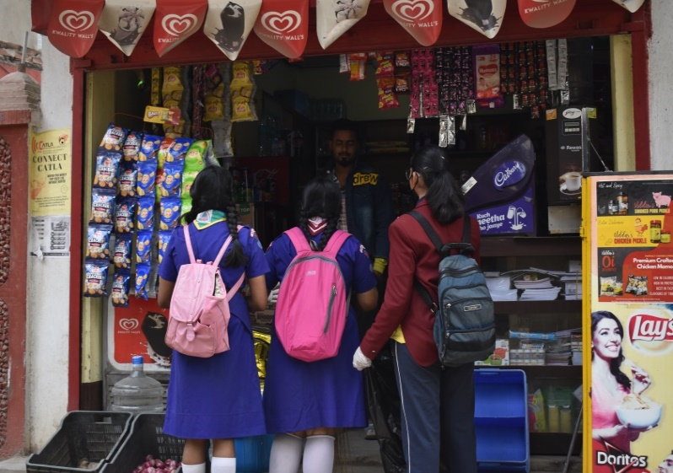
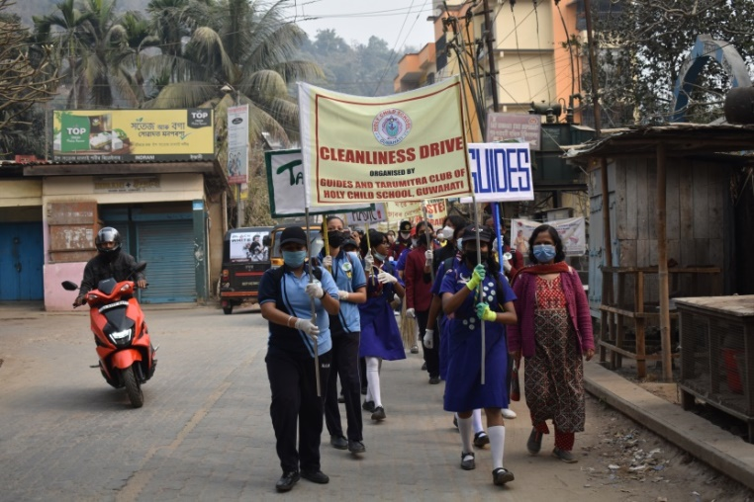
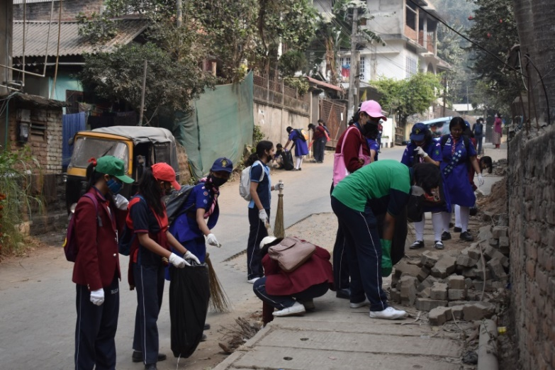

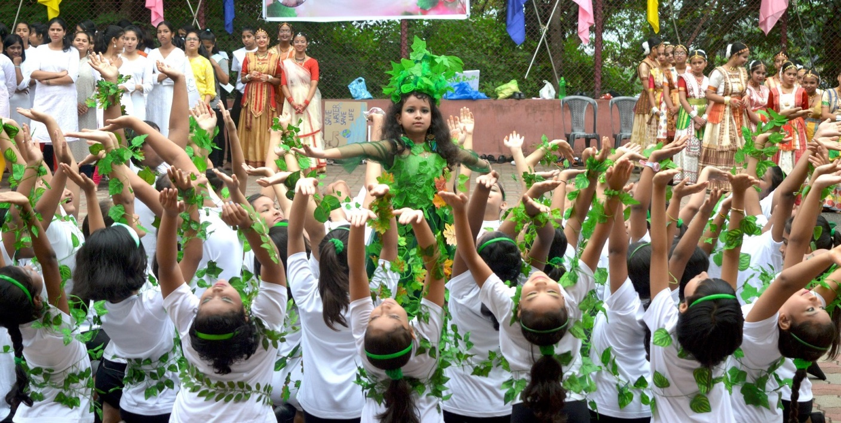
- During the different celebrations, through programmes brought awareness among students, teachers and parents (photo)
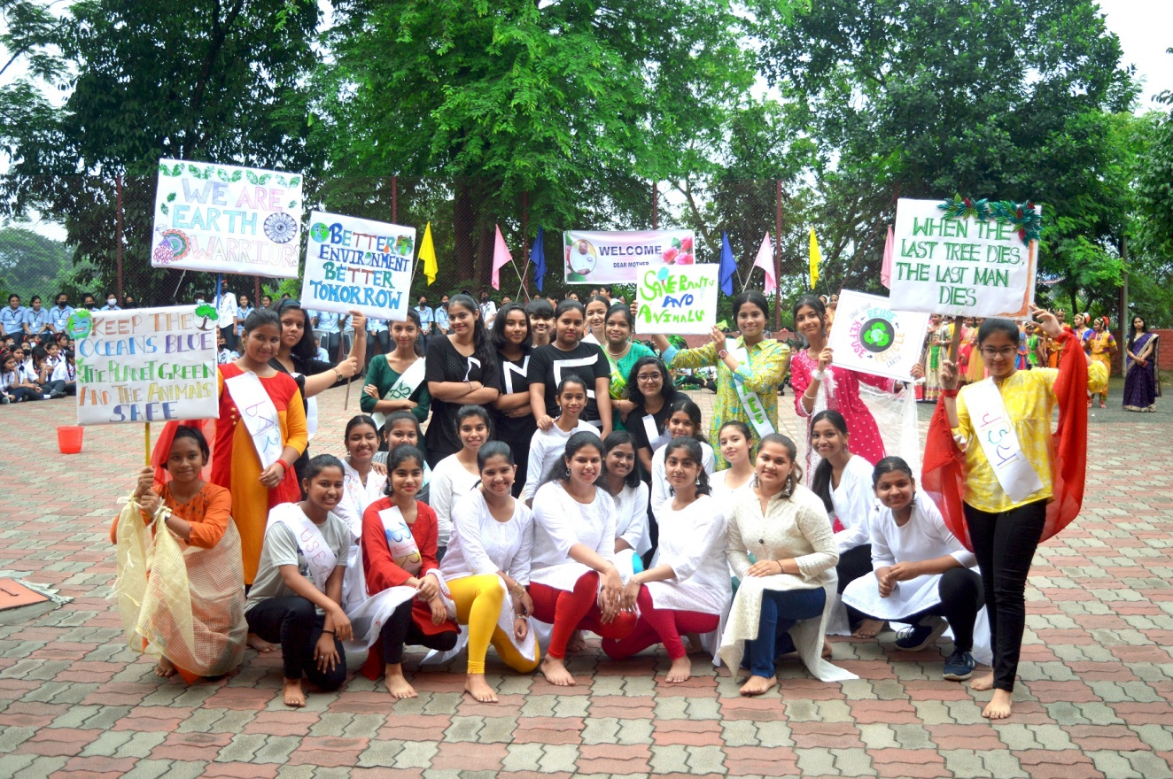

- Eco Club “ Tarumitra” of our school Conducted painting competition based on ecology (5.photo)
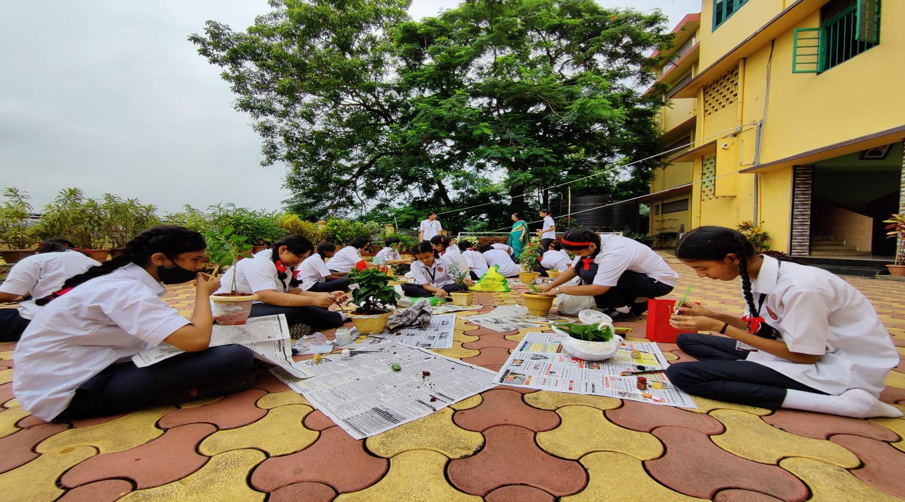
- Adoption of sustainable lifestyle
Organized nature outings and picnics for boarders on the river side and mountains.
(6. photo)

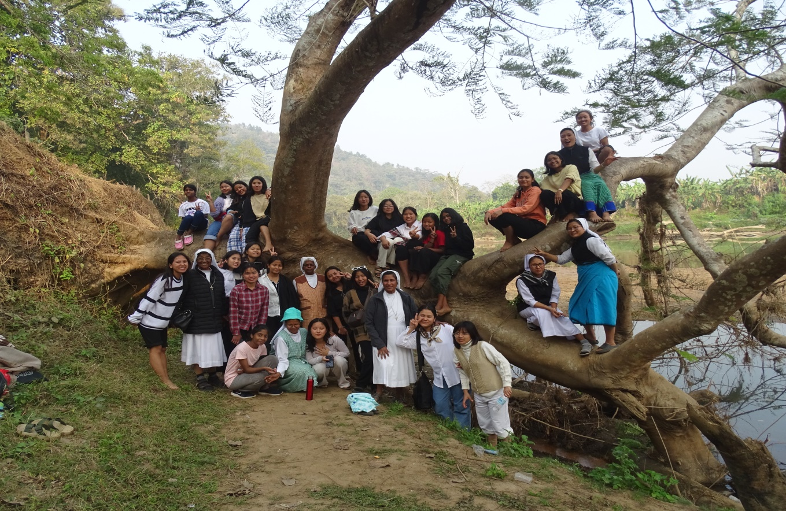
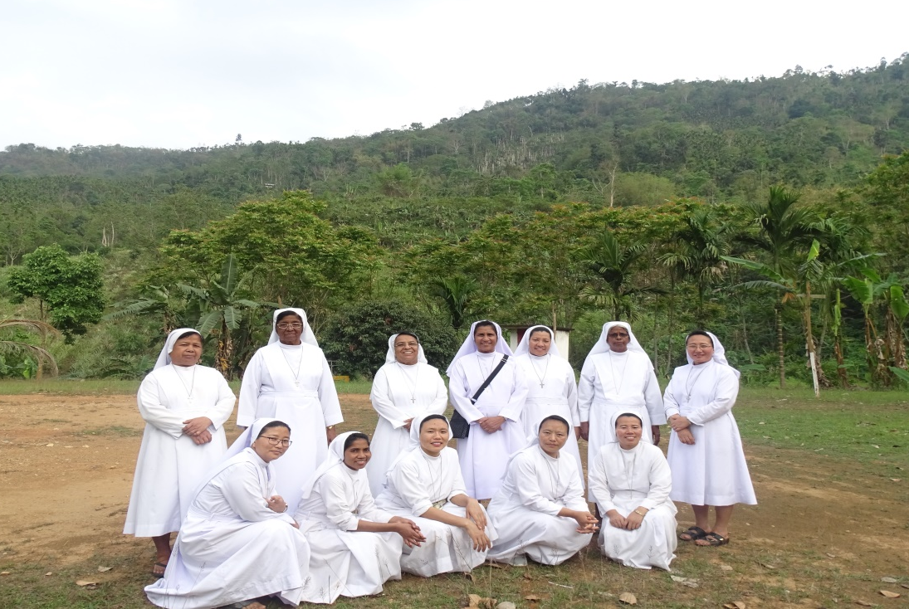

- Ecological Spirituality
- Organised nature meditation for students during the moral science class.
- Celebrated season of creation with parishioners during the Sunday Eucharist
(7 photo)
- The community did a deeper study on the document “ Lodato sii” for better practical understanding of integral ecology.
- Celebrated the environment day and eco days with creative programmes and prayer services.

