St. John of the Cross Parish --- Laudato Si Action Platform Reflection - - - December 2022

St. John of the Cross Parish

To be Church = The Body of Christ

Pray / Serve / Grow

Pray: excellence in liturgy - proclaiming, preaching, and song
Serve: continued outreach to others
Grow: in holiness, vitality, vocations

St. John of the Cross Parish, (SJC) located in Western Springs, IL, is blessed with a dynamic group of uniquely talented and generous parishioners who freely share their spiritual gifts. We are led in faith by a dedicated pastor, parish staff and lay leaders. In all our endeavors our enduring purpose is to be the Church; to be “the Body of Christ”. The three pillars of Prayer, Service and Growth guide our community into various actions that help fulfill our purpose.

In October 2022 SJC enrolled in the Laudato Si Action Platform. (LSAP) Our decision to enroll was made after well-considered research, informed discussion, and prayerful discernment. We believe the LSAP will give our parish the structure and guidance needed to model responsible environmental stewardship while offering concrete and effective responses for those grappling with the humanitarian and environmental challenges of the times. Above all, our enrollment is an Act of Love for our Creator, for one another, and all of Creation.

Reflection is an important initial step in the LSAP enrollment process. In the following text we explore, and evaluate how our Parish mission, values and actions connect with the 2016 Papal Encyclical Laudato Sí “Call to Care for Our Common Home”, Catholic Social Teachings and the Seven Laudato Sí Goals.

Part I: Reflection on Laudato Sí
At SJC we recognize that our Lord has bestowed upon us a precious gift: our natural world and all of God’s Creation within. We also recognize that over time humankind has devalued this gift, and its cumulative neglect is causing our world and its inhabitant’s great harm. We now are called to address one complex crisis that is both environmental and social. To address this crisis Pope Francis, in his 2016 Papal Encyclical, Laudato Sí, called for all people of good will to experience an “Ecological Conversion”; to think differently about human beings, life, society, and our relationship with nature. (LS 2 215)

The LSAP enrollment experience has provided us with a better understanding of our role within the Catholic Church in Caring for Our Common Home. We recognize that the consequences of Climate Change disproportionately impact those with the least resources and representation. And we understand that when we provide care for our environment, we are also providing care for our brothers and sisters. The SJC community acknowledges the complexity of the problems yet dedicates itself to nurturing and protecting all life-sustaining systems within our Common Home.

Our LSAP strategies for solutions and initiatives is informed by the Vatican’s recent endorsement of using an Integral Ecology approach. This approach begins with an understanding that “everything is interconnected”. With an Integrated Approach we plan to widen our lens to consider the following sub-systems in relation to our Parish and our Laudato Si plans and goals:
- Environmental Ecology
- Economic Ecology
- Cultural Ecology
- Social Ecology
- Ecology of Daily Life
- The Principle of the Common Good
- Justice Between the Generations

An Integrated Approach will greatly assist and complement our well-established programs and outreach activities. Our SJC ministries are already firmly rooted in the Catholic Social Justice Teachings, and we strive daily to follow the Principles of Subsidiarity, Solidarity and Synodality.
- We practice Solidarity by treating every neighbor regardless of race, ethnicity, or nationality as ourselves.
- We value Subsidiarity by supporting decision-making and control by people most affected by issues and concerns of their communities.
- We engage in Synodality by collaborating with and considering the needs of all members and community stakeholders.

The seven Laudato Si Goals are inspired by the Laudato SÍ Encyclical. Within the Laudato Sí Action Platform, these goals provide us with an organized framework to center our future actions. We are also able to measure how our current and prior activities already include components of these goals. See Part II of our Reflection for a small sample of how we give care to our brothers, our sisters and Our Common Home with the Laudato SÍ Goals described below.
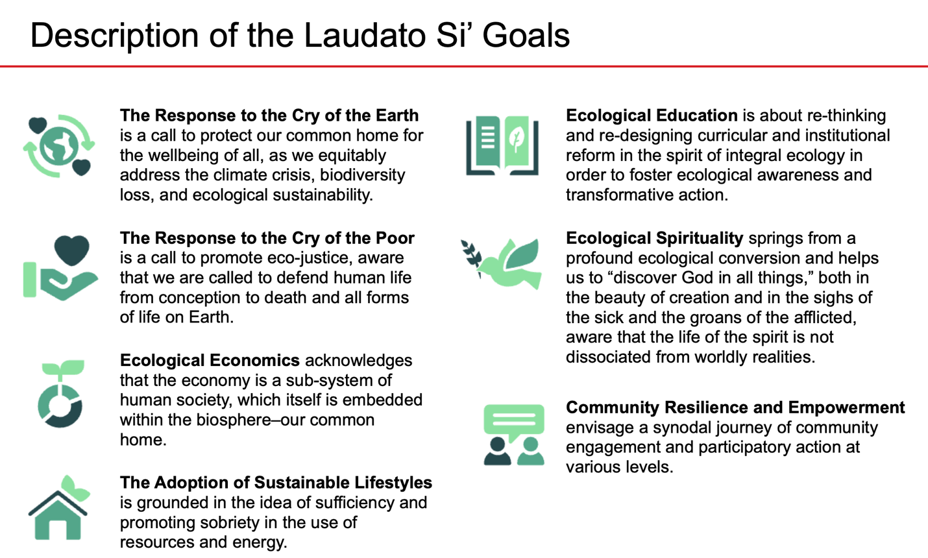

Part II: Celebrating SJC Achievements
Highlighted below is a representative sample of the many activities and programs currently in place at SJC. Weaved throughout these examples one can see how SJC fulfills its mission, as it practices the principles of Catholic Social Teachings while putting Laudato Sí Goals into action.

Response to the Cry of the Earth: Our “Gardening Angels” and SJC Outreach Gardeners work towards protecting and restoring biodiversity by seasonally planting milkweed and asters to protect pollinators. Both SJC Outreach and the Parish School use regenerative agriculture practices in our on-site vegetable gardens and then donate the produce to local food pantries.

Response to the Cry of the Poor: Our SJC Outreach team maintains deep and lasting relationships with vulnerable people and their leaders throughout the Chicagoland area. Likewise, our various ministries and groups continuously raise money and donate food and other necessities to a multitude of organizations.

Ecological Economics: As an employer, St. John of the Cross Parish & School is consistently recognized by the Chicago Tribune as a Chicagoland Top Workplace. Led by Father Reszel, SJC Administration supports its staff by hosting bi-weekly meetings and spiritual retreats, providing continuing education and paying fair living wages.

Adoption of Sustainable Lifestyles: The Parish buildings have LED lighting and low flow water fixtures. The school has also installed water bottle stations to reduce plastic water bottle waste and the students have reinstated a paper recycling program. In promoting the circular economy, the Women’s Club holds an annual community garage sale in which the reuse and repurposing of household items raises money for local non-profits.

Ecological Education: The CARES team publishes bi-weekly bulletin communications about Laudato Sí, ecological/environmental information, community events and other helpful resources. Our Parish School and Youth Catechesis educators incorporate Creation Care and Catholic Social Teachings into their curricula from preschool through eighth grade.

Ecological Spirituality: Our Pastoral and Spirituality teams incorporate aspects of Creation Care into liturgy and homilies, weekly mass petitions, and other programming throughout the year. Events such as the Annual Pet Blessing on the Feast of St. Francis Assisi provides our community with a space to pray outdoors in celebration of animals and nature.

Community Empowerment and Resilience: SJC Youth Ministry fosters leadership and community development with student participation in Summer Work Tours, Harvest Saturday, and other local projects. These activities are done in collaboration with our Renew My Church grouping that includes St. Francis Xavier and St. Cletus Parishes. The SJC Men’s Club partners with our Boy Scout troops to help prepare future Catholic leaders to lead our communities.

Part III: A Call to Action

From the LSAP Assessment and Reflection process we discover many Laudato Sí themes are very much present at St. John of the Cross Parish. Our staff, lay leaders and parishioners care deeply about both the humanitarian and environmental issues our community faces. We are pleased to see Care for Creation in action throughout our parish.

At SJC we find our greatest strength can also be our greatest challenge. A large and vibrant parish with its many functions and services oftentimes uses a decentralized approach for optimal efficiency. For all its benefits however, this approach may impact our progress as we attempt to work together using Laudato Sí Goals to solve current and future social and environmental challenges. To address potential obstacles SJC’s use of an Integrated Approach (when appropriate) will aid us as we embark on this seven-year Laudato Sí Journey.

Finally, this Reflection reinforces the importance of a vested and supportive Parish leadership team. Throughout this process CARES has been met with openness and encouragement from our SJC community members. We are grateful for: Father Marc Reszel who initiated and leads this process, the Parish Staff for their input and guidance, the Parish Council members for their discernment and approval and for our continuous parishioner support.

Pope Francis has called for transformative actions to be made by “all people of good will” and as we fulfill our purpose at SJC “to be the Body of Christ” we are prayerfully committed to answering that call to Care for our Common Home.

