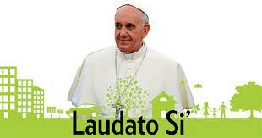
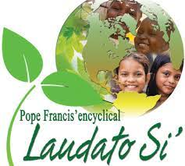

Objectives of Laudato si for the care of
Our common home.

Laudato Si can truly be a teachable moment for children today. Many praises and schools celebrate earth day with special activities, studies on the environment and care of the earth prove to be a perfect time to incorporate cross- curricular activities since the environment can be taught in so many subjects. Some of the issues that Pope Francis discusses are often ideas that are already being taught in the classroom, it is so encouraging to see our children enthusiastically embrace ecology. This generation of children seems to understand the grave importance of the environment for their future and the future of their home-the Earth,
The cyclical takes its name from the invocation of saint Francis of Assisi, praise be to you. my lord which in the canticle of the creatures reminds us that the earth, our common home, is like a sister with whom we share our life and a beautiful mother who opens her arms to embrace us (1)we ourselves are dust of the earth .(gen.2;7)our very bodies are made up of her elements. We breathe her air and we receive life and refreshment from her waters (2)

“laudato si”
On care for our common home

  1. |  | Response to the cry of the earth. Protecting our common home for example: renewable energy sources sustainable agriculture, potable water for all.
2. | 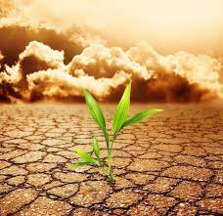   | Response to the cry of the poor, promoting eco-justice, aware that we are called to defend life,
3. |  | Ecological economics. sustainable producing moderation in the use of resources and energy,
4. |  | Adoption of sustainable life styles, fomenting moderation in the use of resources and energy,
5. |  | Ecological education ,fostering ecological awareness and transformative action,
6. |  | Integral ecological spirituality. Encouraging greater contact with the natural world in a spirit of wonder. Praise. joy , and gratitude,
7. |  | Community Engagement. Encouraging the development of cultures and policies that protect our common home and all who share it ,

sr.prema
sisters of st,joseph vas

