

Missionary Congregation of the Blessed Sacrament
(MCBS)
“By learning to see and appreciate beauty. We learn to reject self- interested pragmatism. If someone has not learned to stop and admire something beautiul, we should not be surprised if he or she treats everything as an object to be used and abused without scruple.”
Pope Francis “Laudato Si’”

The members of the Missionary Congegation of the Blessed Sacrament, has a positive approch towards the action plan initiated by Pope himself. The encyclical letter is really an eye opener. As a represntative of MCBS I am very glad that church is responds towards the necessasities of the time. All the religious congregations and the christian institutions positively providing all the nedful. The goals have comprehensive approch towards the whole humanity and the planet. We share a common home, we share common resourses. The life only explores in the coperation and unity. “No man is an island”, the prime responsibility is to protect the our common home.
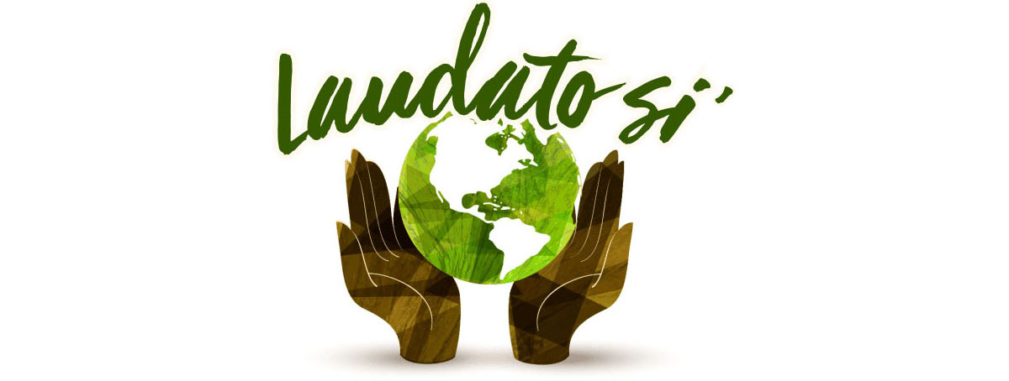
The MCBS congregation is based on the Eucharistic mystery of Christ. We promote the nature and the church together with the salvific mystery of Christ. MCBS does various ministeries in the church based on the eucharist. In eucharist the divine anture and the environment becomes united. The congregation has the vision about the unification of the humanity by building lives centered on the eucharist. In tht vision MCBS undertakes missions to promote and support the people. In every mission I have seen the positie approach towards nature by creating the eco- friendly campuses, in the agricultural fields,etc. I am very proud about the attitude of the congregation toward nature. And I wish let this action platform transform the humanity in appreciating the beauty.

