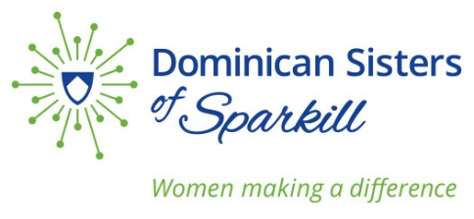
We, the members of the Dominican Congregation of Our Lady of the Rosary, Sparkill, New York, USA publicly commit to join the worldwide Catholic community with prayer and action in support of the Laudato Sí Action Plan
In our Land Ethic, we have embraced the following:
Our shared values and beliefs regarding the earth in general, have grown out of our study of the continuing revelation of God in all of creation, in the Scriptures, in the teachings of the Church, and in human wisdom. Our decisions and actions are shaped by our Dominican heritage, which impels us to seek new vistas of possibility in human and world development.
We have come to understand that care of people and for the poor is inextricably connected to our care for Planet Earth.
We pledge to live a simple life in common, to use and share in a responsible manner, resources entrusted to us by God, and to continually deepen our understanding of the vow of poverty.
In our stance on Climate Change, we commit to:
Lending our individual and collective voice to those efforts, consistent with our Catholic faith and the Dominican search for truth, that seek to mitigate the effects of Climate Change.

Educating ourselves, family, friends, neighbors, and colleagues about global warming and ways to address this challenge.

____________________________________
This is not a new commitment, but rather a recommitment recognizing the interrelatedness of the cry of the earth and the cry of the poor.
Faithful to our Dominican charism, we commit ourselves to the pursuit of truth in order to address more effectively the needs of our suffering world, Climate change, immigration, peace, racism, and the needs of women are some if the issues that cry out for God’s healing power.
– Direction Statement, 2016

