Laudato Si’ Action Plan Reflection Document
A Comparison of our Pastoral Plan with the Laudato Si’ Goals
St. John Neumann Parish, Reston, Virginia USA August 2022
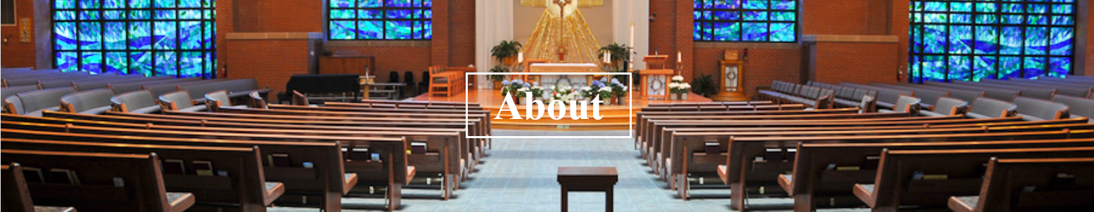
“Be Who You Are and Be That Perfectly Well” St. Francis de Sales
Who We Are
These words of St. Francis de Sales apply to both the St. John Neumann parish and to its members. We are, first of all, a community of those who believe in and follow Jesus Christ in the Catholic tradition. We treasure the heritage of Salesian Spirituality that has characterized the parish from its beginning. We are men, women, and youth who volunteer our time and talents to parish ministries that proclaim the Gospel and bring acts of service and stewardship to the communities we serve. And, as members of our parish, we each accept the responsibility of sharing our financial resources and talents so that St. John Neumann can continue to celebrate and give witness to the presence of God in our midst.
About Our Parish
The parish is located in Reston, Virginia, a growing and changing suburb located about 20 miles west of Washington DC. Founded in 1964, Reston was designed to emphasize planned, self-contained communities that intermingled green space, residential neighborhoods, and commercial development. As the number of families and Catholics in the area has grown at an amazing rate, so too, has the parish grown - from 800 families to over 4,100 families. It continues to add 40 families a year. In addition, over 700 children participate in the Religious Education program each year. A Spanish mass was added in 2003 to serve the growing Hispanic community.
The one constant has been the presence of the Oblates of St. Francis de Sales. Since the founding of the parish in 1979, the Order made a commitment to staff the parish with its own Oblate priests. Salesian Spirituality is embedded in the parish Mission Statement – “May we do all things in the spirit of St. Francis de Sales with compassion, humility, and gentleness.” Salesian Spirituality makes St. John Neumann attractive and different from most other parishes in the diocese, as evidenced by the high percentage of members who reside in areas outside of the traditional parish boundaries. The parish is fortunate to include many generous parishioners who respond to special needs both locally and globally, including the needs of our sister parish, Nino Jesus, in Ecuador.
Our Pastoral Plan
The Parish Pastoral Plan sets forth our strategic direction and objectives for 2021-24. It renews the commitments made in the 2017-20 Plan to the five parish areas, and establishes new objectives under each to drive our Parish forward and meet the challenges of our time. Input from the members of St. John Neumann—gained through a Parish-wide survey, engagement sessions, and other forms of dialogue—was integral to the molding of this new Plan. It helped us to identify areas where our Parish is vibrant and strong, as well as to identify opportunities for us to more fully respond to Jesus’ summons of us into His harvest.
One of the specific objectives in the Pastoral Plan is to “embrace Pope Francis’ seven-year Laudato Si’ Action Plan by developing a multiyear approach to increase sustainability in the holistic spirit of integral ecology.”
How the Pastoral Plan aligns with Laudato Si’ Goals
As requested in the Laudato Si’ Action Platform, we took time to see how the values of the parish, as expressed in the Pastoral Plan, compared to the values expressed in the seven Laudato Si’ goals. We found that the Pastoral Plan pathways did not easily match up with a single Laudato Si’ goal. Rather we found multiple connections (as illustrated in the diagram below) in which the values of the parish corresponded to the values expressed in Laudato Si’. While we believe we are doing many things at our parish in the spirit of Laudato Si’, we must not be complacent.
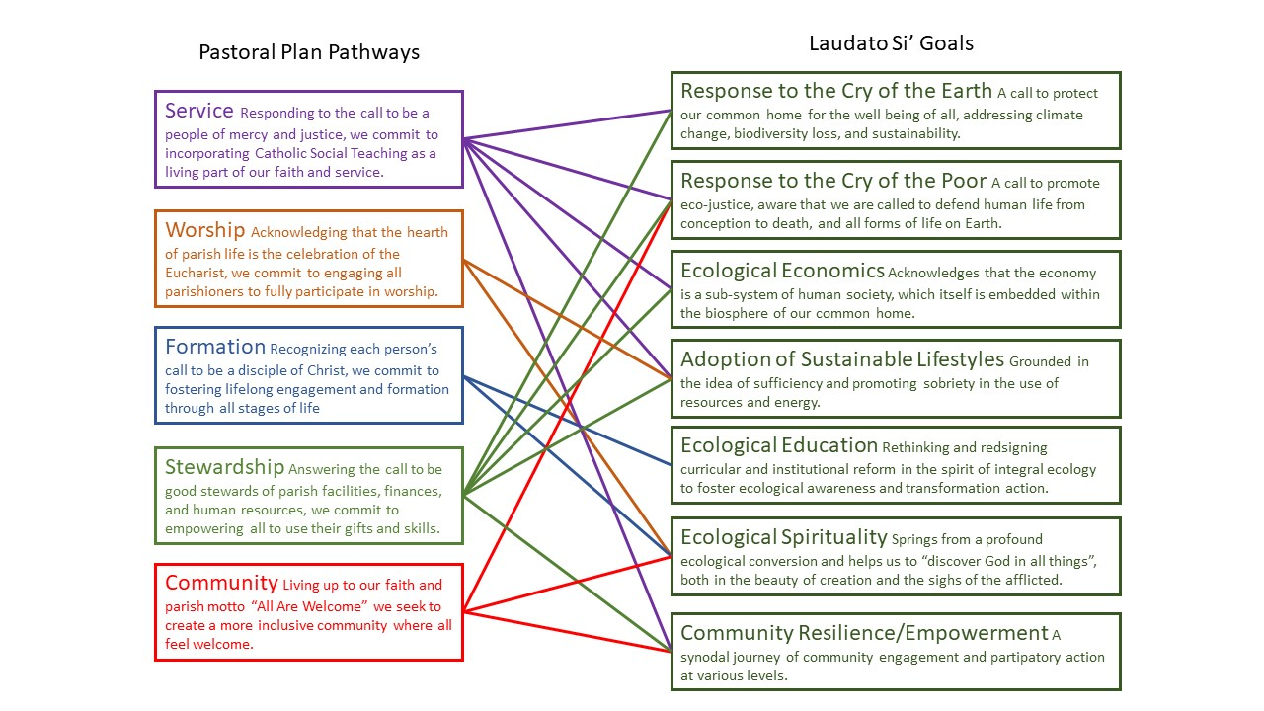
The above chart shows that there are definite alignments between our pastoral plan and the goals of Laudato Si’. Some of the connections are strong because the Laudato Si’ values are well grounded in our parish mission. Other overlaps between the two sets of goals are weak because only a small percentage of parishioners are involved with or aware of the ministry or activity.
To illustrate how these connections are being lived out at our parish, we include in this Reflection Document five stories: one for each of the pastoral plan objectives. These five were drawn from an abundance of powerful personal testimonies. Know that these five accounts stand in for a full chorus of faith encounters. They demonstrate how our parish is currently living Laudato Si’.


STEWARDSHIP OBJECTIVES
Pastoral Plan: St. John Neumann commits to being a good steward of the parish facilities, finances, and human resources that enable the community to pray, grow, and serve. Stewardship also involves empowering parishioners to use their gifts and competencies on behalf of the faith community, providing the necessary pastoral formation and support.
Story
The parish holds an annual Mardi Gras dinner to raise funds for the Work Camp program, which provides teens with an opportunity to encounter Christ through service, faith, and fellowship. Responding to Pope Francis’ warning about the “throw-away” culture of consumption and waste, the dinner was organized as a “near-zero waste” event. Multiple parish ministries worked in solidarity to make the event a success. The Knights of Columbus did the cooking, the Contemporary Choir provided musical entertainment, and the Care for Our Common Home ministry managed the cleanup. And best of all, the teens themselves took ownership of the event by serving food, bussing tables, segregating waste, and washing dishes. Single-use paper and plastic items were replaced with washable plates, serving utensils and compostable cups. Bottles were recycled and food scraps composted. The result greatly reduced waste generated by the 250 parishioners who cheered “Laissez les Bons Temps Rouler” prior to their Lenten journey.
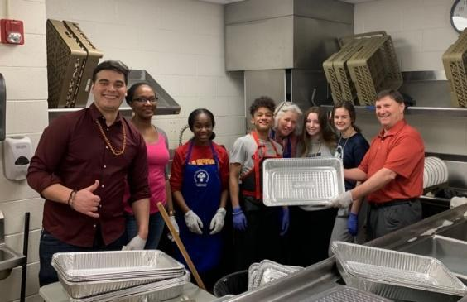
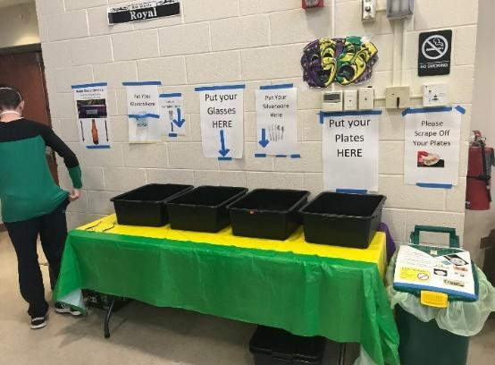
The connections between the parish’s call to empower parishioners to use their gifts and talents match well with the Laudato Si’ goals of hearing the cry of the earth, adopting sustainable lifestyles, providing ecological education, and empowering the community in participatory action. This is one example of reducing waste. Others include dishwashing at the Hypothermia Prevention Shelter, the Live Jesus Salesian retreat, the Oktoberfest celebration, numerous funeral receptions, and other smaller parish functions.


COMMUNITY OBJECTIVES
Pastoral Plan: Living up to our faith and our Parish motto “All Are Welcome,” we seek to create a more inclusive community where all feel welcome.
Story
The Starkist story is a story of success for so many groups because of collaboration. A great idea came to fruition because critical players each said “yes.” When the Starkist Tuna company moved into Reston recently, they wanted to connect with the needs of the local community. It didn’t take them long to connect with Feed the Children who suggested the idea of summer relief care packages. And it didn’t take them long to in turn reach out to Cornerstones, a local organization that helps neighbors in need. And they, in turn, didn’t take long to connect with our church to provide the setting for the distribution.
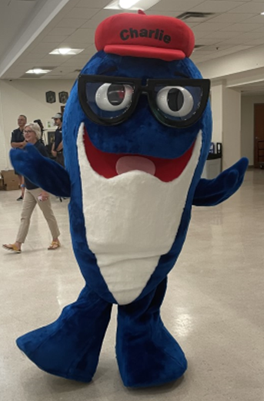
That “domino effect of an idea put into action” was played out in our parking lot. Imagine the setting- a tractor trailer full of boxes, a fork lift zipping around to get the boxes into po sition, a DJ playing music, seventy volunteers getting boxes into cars, and a long line of cars with children hanging out of the windows taking in the festive spirit. And of course, Charlie the Tuna was hamming it up with every family. Each of the 379 families received a box of pantry staples (with, you guessed it, tuna fish), a box of hygiene essentials including high quality beauty products, and a box of new books for children who are home for the summer. The distribution was a win for everyone.
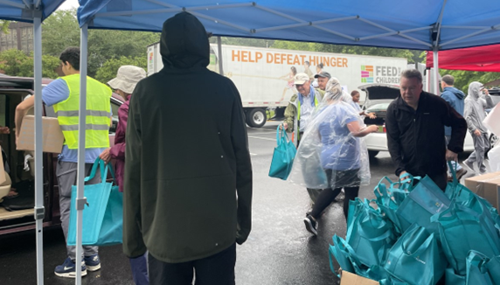
The Laudato Si’ culture is all about connectedness and this story is one of many examples of how SJN is connected to the community, especially through local outreach services. Because of those long standing, strong relationships, we are often honored to be the final connection point of a long line of aid to those in need, allowing us the honor to see and serve Christ in the marginalized of our community.

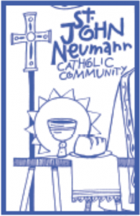
WORSHIP OBJECTIVES
Pastoral Plan: The heart of parish life is the celebration of the Eucharist, from which flows all our worship, sacraments, and prayer. St. John Neumann encourages the full, active, and conscious participation of all parishioners in the sacramental life of the Church.
Story
Step onto the grounds of St. John Neumann and you can’t help but be awed by the scenery. Even in the heavily developed suburb of Reston, our church is surrounded by rich woods crisscrossed with walking paths. One of these paths is our prayer loop, where parishioners can pick up cards printed with meditative prayers and walk a short way among oaks, hickories, and hollies.
Throughout the year, we host guided walks through the
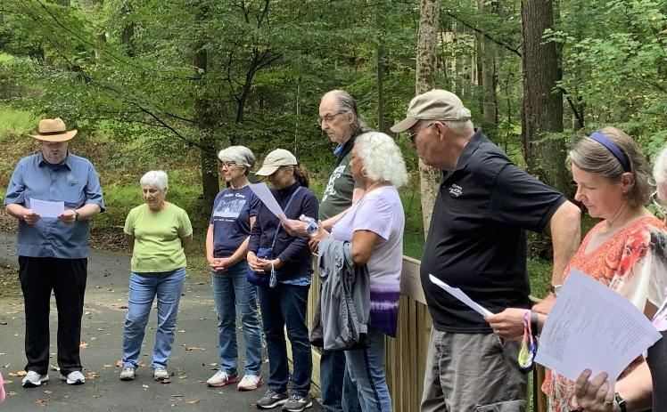
more extensive network of trails nearby. We celebrated Earth Day 2022 with one such walk. After an opening prayer, we took to the woods. The trees had not yet unfurled their leaves, and native wildflowers like Virginia bluebells, toadshade trilliums, and Solomon’s seal were blossoming throughout the forest floor. An experienced bird watcher directed our eyes and ears to native chickadees, wrens and thrushes. We also heard the calls of migrating warblers and grosbeaks using our wooded stream valley as a welcome stopover on their way north.

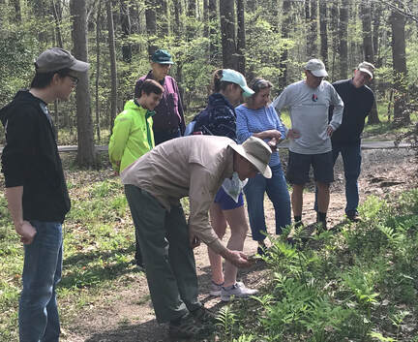
As we walked, we noted a number of non-native species populations like garlic mustard and lesser celandine, which seem lush and lovely but which out-compete the local species. We considered the parallels to our faith lives - that temptation can be attractive but inhibits us from flourishing. The natural sporadic pruning of the outer tips of the oak trees by the recent cicada brood reminded us of the healthy feeling we experience after the sacrament of reconciliation.

As a parish we not only care for the beautiful grounds on which we worship, but we have also found ways to make it an active part of our prayer life. Our proximity to nature gives us a chance to learn from and contemplate God’s creation.


FORMATION OBJECTIVES
Pastoral Plan: St. John Neumann aims to foster and empower each person’s call to be a disciple of Christ through effective faith formation and spirituality. Preparing our parishioners for mission requires a variety of educational and faith formation programs for all ages.
Story
St. John Neumann’s youth and young adult faith formation draws families from across the diocese. Rooted, St. John Neumann’s middle school formation program, uses engaging, original material to meet students where they are on their faith journey. Throughout their sessions, Rooted students learn about the life of the Church, exploring sacraments, saints, scripture, and service in creative ways. This unique program was developed by one of the staff at SJN and reaches 275 youth in grades 6-8. Over 65 adult volunteers help make the rotating small group model run smoothly.
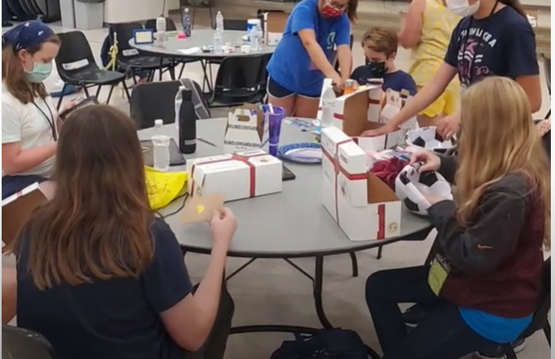
One Sunday afternoon, Rooted students completed a scripture scavenger hunt, bouncing animatedly from station to station around the church, reading key passages from scripture focused on the Eucharist. At each, students chatted with each other and their instructors about being a part of the body of Christ, and how we are all called to the table of Communion.
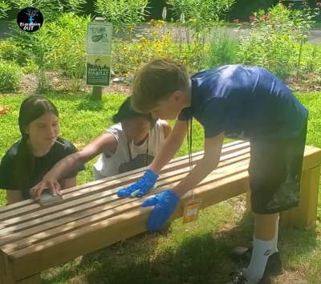
But it wasn’t just fun and games: during their closing retreat, the students completed a service project packing 40,000 meals for Cross Catholic Outreach, for which they’d spent the prior months fundraising and preparing. They worked diligently and excitedly, completing their goal with time to spare.
The flexible, fun, and focused nature of Rooted helps support middle schoolers to see the diversity and interconnectedness of spiritual life - encouraging their curiosity and enthusiasm while stressing the importance of serving our neighbors near and far.


SERVICE OBJECTIVES
Pastoral Plan: Responding to the call to be a people of mercy and justice through compassionate service, we commit to incorporating Catholic Social Teaching as a living part of our faith and service.
Story
When someone asks how an outreach ministry began at our parish, the answer is typically, “From a graduate of Just Faith.” The Just Faith (JF) program is a hidden treasure of SJN and it is always inspiring to see what fruits blossom after each class completes the course. Luckily, our clergy and staff are always welcoming new ideas and they heartily support the JF grads in bringing ideas to fruition. It is a ministry that has been informing and transforming St. John Neumann parishioners, so they can then transform the parish.
JF is a nine-month course in which root causes for poverty and injustice are explored through readings and videos. One month, the group is studying racial justice, watching historical news footage, reading books and articles and discussing what’s been learned. The next month, there’s a deep dive into climate change and particularly how it is affecting the poor. Scientific findings, papal documents, documentaries from islanders losing their homeland – it’s all digested and looked at through the lens of Catholic Social teaching. Each month, a new issue is presented and the participants are guided to finding practical responses to the call of the marginalized in our community, in our nation and in our world.
The program aligns perfectly with the goals of Laudato Si’. After our minds are informed, our hearts are softened and then we are ready to bring mercy and justice to others. This describes the ecological conversion that Laudato Si’ urges for “all people of good will.”
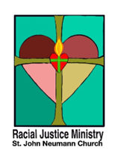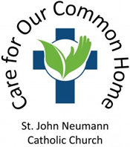

How Can We Deepen the Pastoral Plan to Align with the Laudato Si’ Goals?
In developing this Reflection Document, we have discerned several areas where we wish to more fully align parish goals with the goals of Laudato Si’. Our motto is “All are welcome” and we continually strive to live out this proclamation. We realize that we can better incorporate the Cry of the Earth when we make many of our decisions. We also realize that we should strengthen our efforts to unify our English- and Spanish- speaking communities as we journey toward holiness. We now realize that we need to recognize and respond to the root causes of why the earth is crying out and why the poor are crying out.
Our reflection has shown us the following ways that we might deepen our pastoral plan.
We offer many opportunities for service as we hear the cry of the poor. We can increase parishioner involvement by offering activities for all ages and all groups in the parish. By providing hands on activities, especially outside in nature where environmental issues can be incorporated, we can also hear the cry of the earth.
We have impactful and moving liturgies. We can incorporate the powerful Salesian connections between nature and our spiritual life into both our English and Spanish liturgies.
We have a robust faith formation program. We can include the rich lessons of Catholic Social Teaching to all ages and for all groups. We can improve accessibility by considering multilingual options, accommodating a variety of schedules, providing virtual options and transit solutions.
We model sustainable practices at the church for others to replicate at their homes. We can do a better job of sharing those practices with all ministries and all groups, and applying those practices in our homes.
We are a parish that is hospitable and welcomes all. We can consider the physical impact of our hospitality by developing an ethical purchasing process that takes into account the true cost of an item, not just the bottom dollar.
We are a pro-life, anti-racist parish with ministries that proclaim the dignity of all life. We can do a better job of including more parishioners in the many initiatives that proclaim the dignity of all life, all cultures, all intellectual and physical abilities, and all of God’s creation.
Our church, rectory and grounds are well maintained and have excellent fiduciary oversight. We can consider the impact to the environment in all our maintenance activities, including on biodiversity, pollution, use of energy and unnecessary waste of resources.
In order to fully function as a Laudato Si’ parish, we aim to incorporate the concepts of integral ecology into all aspects of parish life. With every decision or proposed action, we might ask:
1) Does this help us grow in our relationship with Christ?
2) Does this help develop relationships with each other, especially those in need?
3) Does this positively impact the environment?
If our answer is no to any of those questions while planning an activity, we will reflect and look for adjustments to address the issue.
We appreciate the opportunity to reflect on how our parish is living Laudato Si’ and we look forward to the next step of developing an action plan for each of the next five years. We can imagine a sustainable, spiritual, service-oriented parish and are ready to work to make that happen. Laudato Si’ mi signore!

