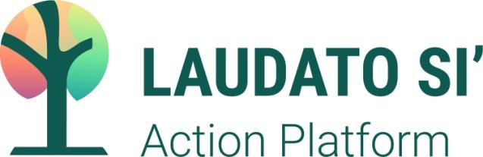

Commitment
Religious Communities

Congregation of the Sisters of Bon Secours of Paris
Name of Congregation

Congregation of the Sisters of Bon Secours of Paris
Laudato Si’ Action Platform Commitment Statement

We, Women of Healing, commit ourselves to:
defend and care for all creation and to
cry out with others against injustice and all that diminishes life on Earth.
Sisters of Bon Secours Mission Focus

In fidelity to this mission focus
that has guided our Congregation choices since 2009
and desiring to live our healing charism more deeply,
the Congregation of the Sisters of Bon Secours and the Bon Secours Family
joyfully embark on a seven-year journey with the universal Church
toward integral ecology in the spirit of Laudato Si’.

Impelled by the Holy Spirit
and renewed by the fire of our original call,
we, women of audacious hope,
commit ourselves to boldly live our charism of
compassion, healing and liberation
with those in our Bon Secours Family
as we address the seven Laudato Si’ Action Platform goals:
To respond to the cry of Earth and the cry of the poor,
Adopt a more sustainable lifestyle
Engage in and foster ecological education
Develop an ecological spirituality
Embrace ecological economics and
Advocate for public policies that protect our common home and all those who share it.

Through our participation in the Laudato Si’ Action Platform,
the Congregation of Bon Secours and the Bon Secours Family
are walking a “path to renewal” together with all people of good will
who love and care for our common home, Mother Earth.
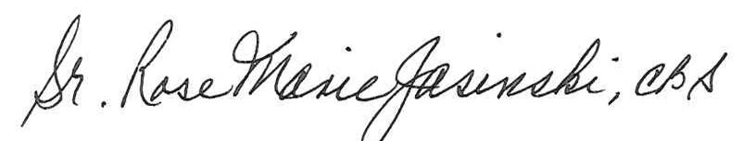

_________________________________________________ Date: October 4, 2021
Signed by General Superior/Major Superior/Community Superior

Laudato Si’ Action Platform contact person (if available)

Name: Mary Beth Hamm, SSJ

